

|  |
| --- |
| Big Cash App |
|  |
| PRODUCT NOTE |
|  |

Table of Contents

CHAPTER 1: REAL MONEY GAMING 6

About 6

Introduction to BigCash 6

Games in BigCash 7

Onboarding process 8

Onboarding Process in BigCash 8

Add Cash 15

How to enter game (example of Fruit Chop) 18

Portal description 22

Card Games 22

Poker 22

Leaderboard 23

Rummy 24

Callbreak 25

Casual games 26

Fantasy Games 28

CHAPTER 2: CARD GAMES 29

Poker 30

Objective 30

How to enter Poker 30

Turn Action 31

Check 31

Turn Timer 32

NL Holdem 32

Leaderboard 34

Game play 35

PL Omaha 37

Game Play 38

How PL omaha differs from NL holdem 40

Hand Strength 40

Example of a gameplay 42

Winning prize Calculation 46

Terms and condition 46

Call Break 47

How to Enter in Call Break game 47

Objective 47

Contests 48

Game play 48

Evaluation of points in call break 50

Other Call break card game Rules 50

RUMMY 51

About 51

How to enter in rummy 51

Objective 52

sequence 52

sets 53

Point rummy 55

About 55

Entry fee, winning and platform charges. 55

Point Rummy Game Play 55

Pool rummy 57

About 57

Entry fee, winning and platform charges. 57

Deal Rummy 58

About 58

Point Calculation in Deal Rummy. 58

Entry fee, winning and platform charges. 58

Special Terms of Big Cash Rummy 59

TERMS for Big Cash Rummy 59

Game of Skills 60

CHAPTER 3: CASUAL GAMES 61

Play Off 62

Bulb Smash 62

Knife Hit 64

8 Ball Pool 66

About 66

Contest, entry fee and winnings 66

Candy Cash 67

About 67

Entry fee, winning and platform charges. 69

MULTIPLAYER GAME 69

Egg Toss 69

How to Enter in Egg Toss 69

Rules and Regulation 70

Game Play 70

Contests 70

Ice Blaster 72

How to Enter in Ice Blaster 72

Rules and Regulation 73

Game play 73

Contests 74

Basketball 75

How to Enter in Basketball 75

Rules and Regulation 76

Game Play 76

Contests 77

Fruit Chop 78

About 78

How to Enter in Fruit chop 79

Game Play 79

Game ends 80

Contest, entry fee and winnings. 80

Soccer 81

About 81

How to Enter in Soccer 82

Game Play 82

Game Ends 82

Contest, entry fee and winnings 82

Cricket 84

How to Enter in Cricket 84

Rules and Regulation 85

Game Play 85

Contests 86

Car Race 87

About 87

How to Enter in car race 88

Game Play 88

Game Ends 88

Contest, entry fee and winnings 89

Big Ludo 91

About 91

Game Play 91

Contest, entry fee and winnings 92

Fast Ludo 92

About 92

Game Play 92

Contest, entry fee and winnings 93

CHAPTER 4: FANTASY GAMES 94

Fantasy Cricket 94

About 94

How to Enter in Fantasy football 94

Objective 95

Game Play 95

Note 96

Contest Table 96

Fantasy Football 98

About 98

How to Enter in Fantasy football 98

Rules and Regulation 99

Game Play 100

Note 100

Contest, entry fee and winnings 100

CHAPTER 5: POKER T.v 102

About 102

How to watch Poker TV 102

CHAPTER 6: INVITE AND EARN 104

About 104

BIG CASH Invite and Earn program 105

Benefits 106

Invite and Earn Monthly Contest 106

Prize Table (for Referral Contest). 108

Terms and Condition 108

CHAPTE 7: Redeem And BigCash Wallet 109

Process 109

Terms and condition for redeem 112

BigCash wallets 112

CHAPTE 8: Revenue 113

About 113

BigCash Revenue process 113

Convinence fee 114

Card Games ​ 114

Casual Games ​ 114

Fantasy Sports​ 114

Revenue model 115

# CHAPTER 1: REAL MONEY GAMING

## About

Gaming Industry all over the globe has made an amazing growth in the past few decades. Real money gaming has proven to be an extremely comforting, and skill requiring concept for earning money anytime and anywhere.  A decade ago, the real money gaming concept was completely mysterious for the Indians. But, with growing technology, easy digital payments, and high-speed internet facility it has been a new era for gaming industry with real money gaming. Real money Games are ones that charge an entry fee from players, unlike other casual games which are primarily dependent on advertisement revenue.

## Introduction to BigCash

Big Cash is a skill-based play and earn multi gaming platform in India. Big Cash has been the Indian gaming mobile industry since 2016. At present Big Cash offers 17+ real money games in card games, casual games which includes one vs one and multi-player games, fantasy sports. At present Big Cash holds 1.7 million average Monthly Active Users of which Daily Active Users are about 450,000. Big Cash.

Other than real cash games, Big Cash app also has a refer and earn program where users can also earn by referring the Big Cash app to their friends or family members. User will earn Rs.30

(configurable) when someone will use your referral link to sign up in Big Cash App and will do his/her first deposit. Also, there are few conditions that users will have to keep in mind for the referral contest that is explained thoroughly in the Refer and Earn section.

# Games in BigCash

Games

**Card Games**  **Casual Games** **Fantasy Games**

 Poker Cricket

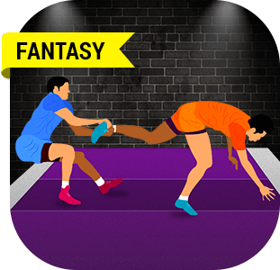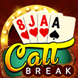 Rummy Football

Call Break Kabaddi

- Play Off Multiplayer

 Knife Hit Egg Toss

Big Ludo

 8 Ball Pool Ice Blaster

 Bulb Smash Basketball



 Fruit Chop

Fast Ludo

Candy Cash

 Car Race

 Cricket Cash

Soccer

# Onboarding process

## Onboarding Process in BigCash

**Follow the following steps to onboard on Big Cash platform.**

Go to [www.bigcash.live](http://www.bigcash.live)

Click on download option and download the app.

After installation, open the Big Cash App where user will get the option to sign up using Facebook or Google.

Register phone number through OTP/ True caller verification

Go through the app.

\

GAMES MENU

**Explanation through visuals is as follows:**

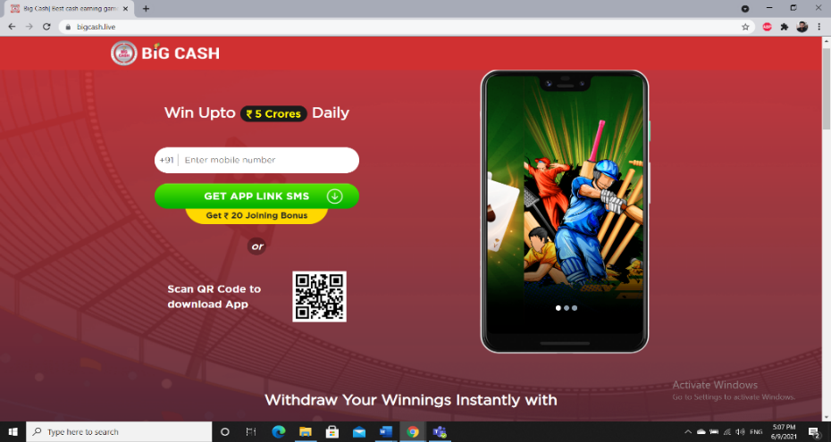**Step 1:** Go to [www.bigcash.live](http://www.bigcash.live), enter your mobile number to get the app link via SMS or directly scan the QR code and get Rs. 20 as a joining bonus.

**OR**

In case you receive referral link from anyone then click on the link in the message you will be directly redirected to the Big Cash page to download the app.

**Step 2:** Click on the link received through SMS and download the Big Cash app. (In case you want the download link through SMS in your phone, you can put your number on Big Cash website in each section.)

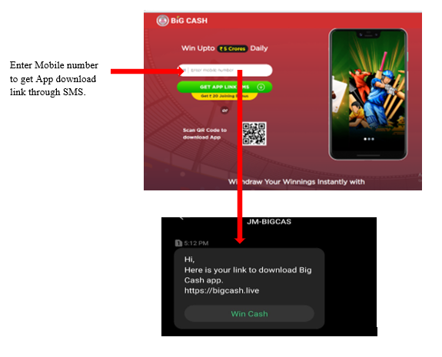

**Step 3:** Proceed with the Installation and allow installation from unknown sources if asked.

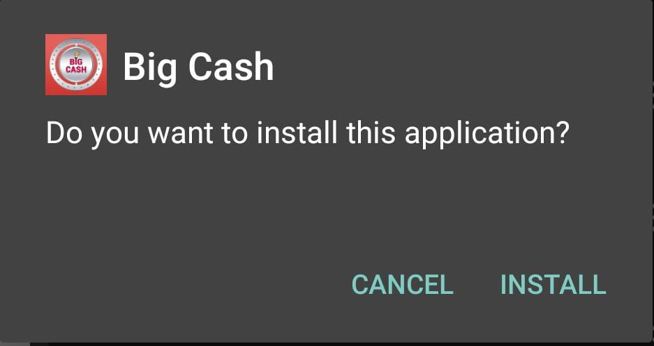

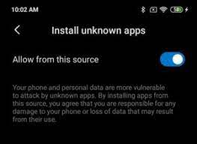

**Step 4:** Big Cash app will request you to allow access to your device location. To continue with the onboarding process, you can choose the option **ALLOW ALL THE TIME** or **ALLOW ONLY WHILE USING THE APP** and if you tap on **DENY** then your onboarding process will be discarded.

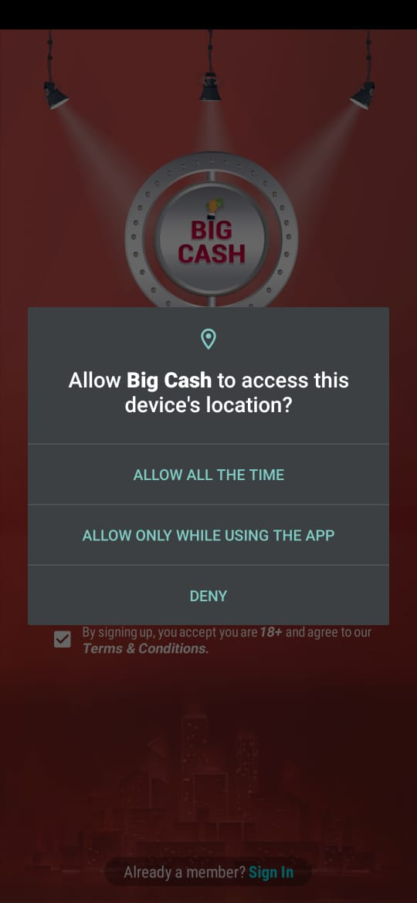

**Step 5:** Open the app.



In case of **new user** register yourself with Facebook (get Rs. 20.00 as bonus) or Google.

In case of **existing user** proceed with Sign In option.

**Step 6:** If you choose Facebook for sign Up/In

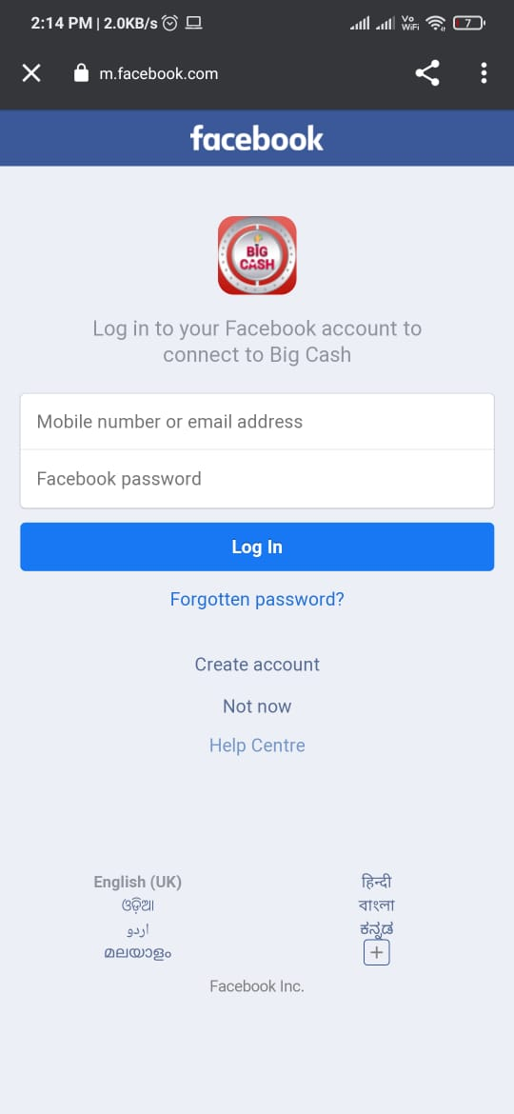

Enter your e-mail id/mobile number and Facebook password and tap on the Log In button.

**NOTE:** If you enter incorrect details, an error will be displayed by Facebook else you will be redirected to BigCash app home page.

**Step 7:** If you tap on Google for Sign Up/In

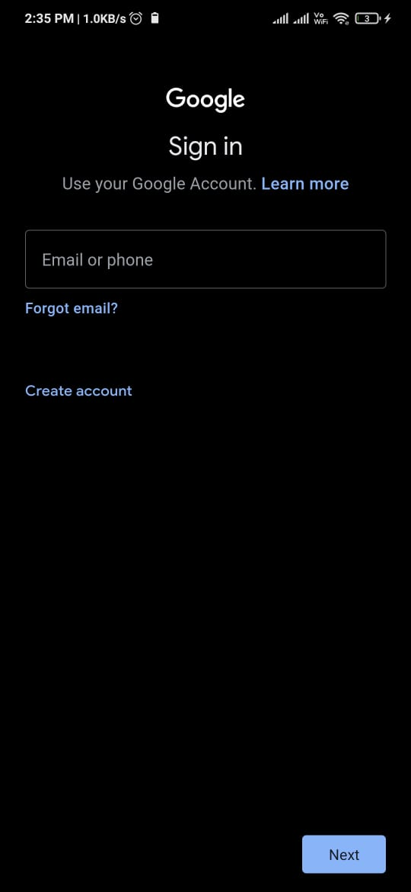

Enter your e-mail id then NEXT and Google password and tap on the Log In button.

**NOTE:** If you enter incorrect details, an error will be displayed by Google else you will be redirected to BigCash app home page.

**Step 8:**  Once Singed in/Up and redirected to the main page. Verify the phone number by OTP or True caller verification.

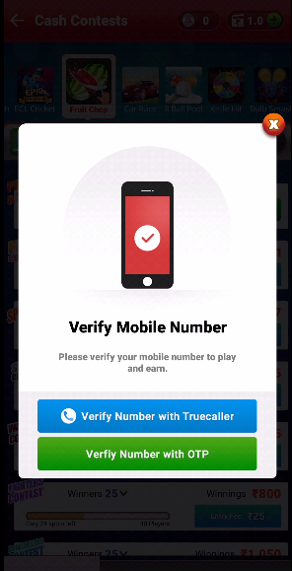

**Step 9:** Enter the number and the OTP received after submitting the number.

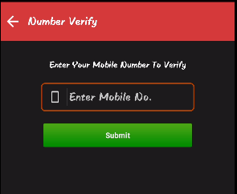 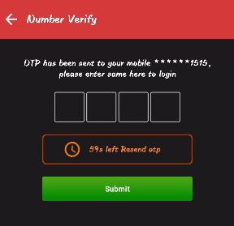

**Step 10:** Check out the menu and games.

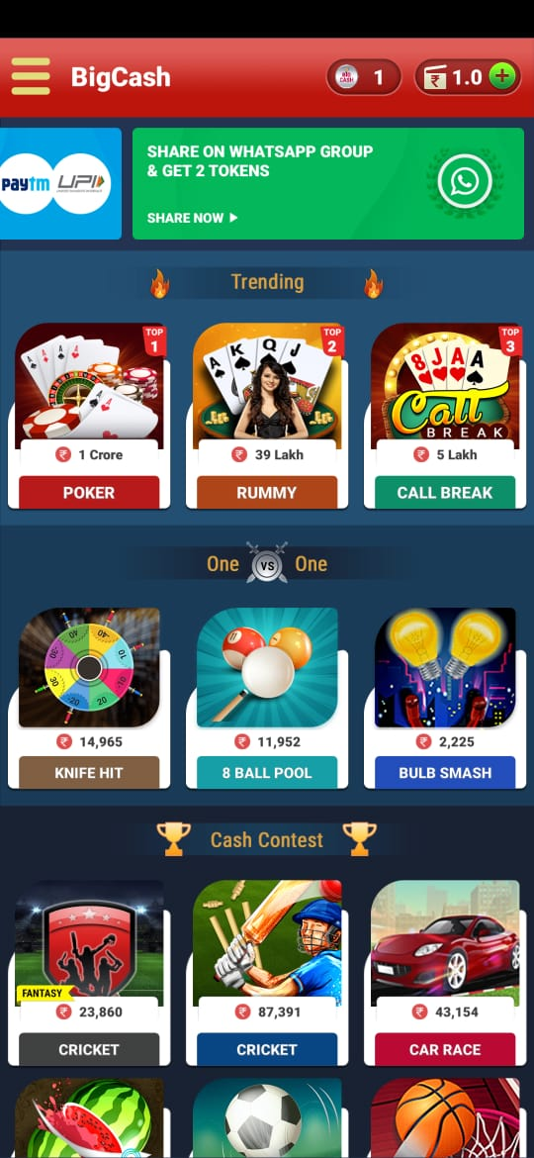

**Step 11:** Go and start playing games.

Big Cash offers 17+ games including card games, casual games, and fantasy games.

## Add Cash

As Big Cash is the real cash gaming platform so the games can either be played with cash or tokens (get while adding cash, playing causal- free/ practice game and in daily spin wheel)

To enter and participate in the cash contests, add cash must be from Paytm, UPI, Net banking etc. Steps for adding cash in Big Cash are as follows:

Go to the Add Cash menu or simply tap the plus ‘+’sign on the top right corner of the home page.

Check out the offers and reward and then enter the amount to add.

Pick a payment Option (Paytm/UPI/Debit Card/Credit Card/ Ponape/Net Banking/Big Cash wallet.)

Proceed with the payment merchant by entering your PIN or other required credentials

Confirm the amount to be added

Add cash done successfully (that will reflect in the transaction history in Big Cash App as well)

Select the game and contest you want to play and enjoy

**Step 1:** open the Big Cash app.



**Step 2:** Proceed with **Add Cash** by tapping on the ‘+’ sign in the home page or go to menu and click on **Add Cash.**

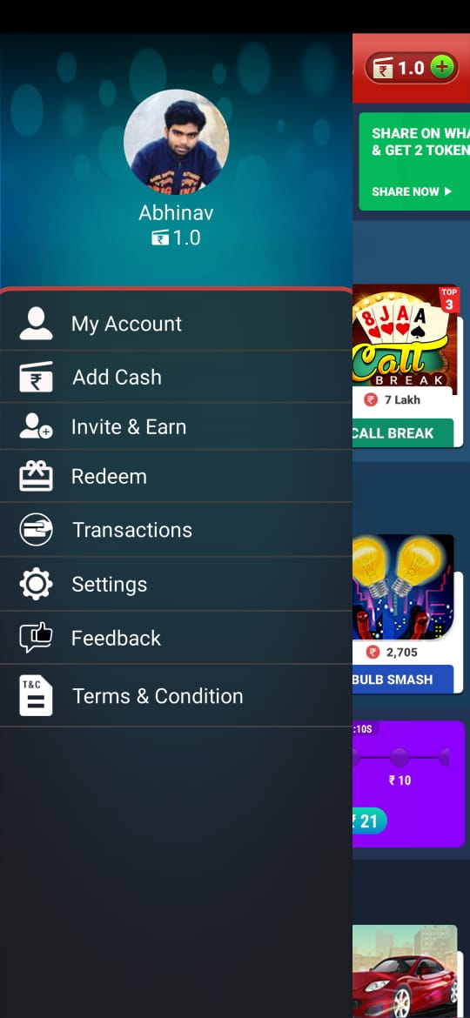

**Step 3:** Check out the offers and reward and then enter the amount (minimum Rs. 20.0) to add.

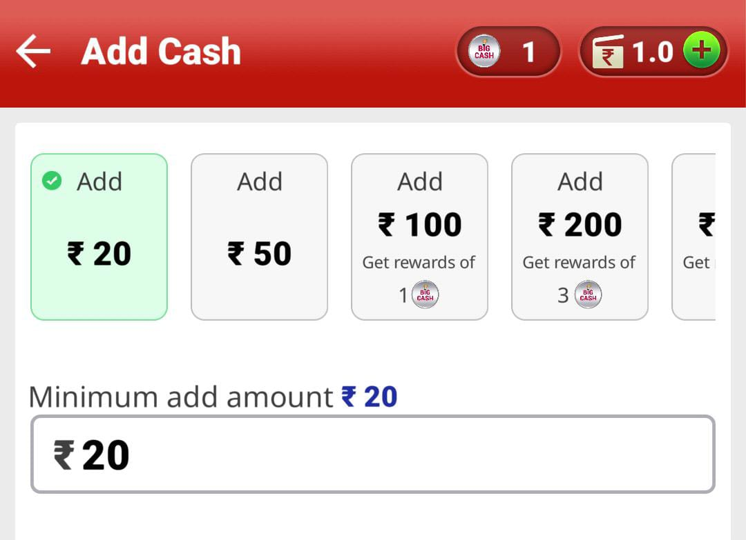

**Step 4:** Pick a payment Option (Paytm/UPI/Debit Card/Credit Card/ Ponape/Net Banking/Big Cash wallet.)

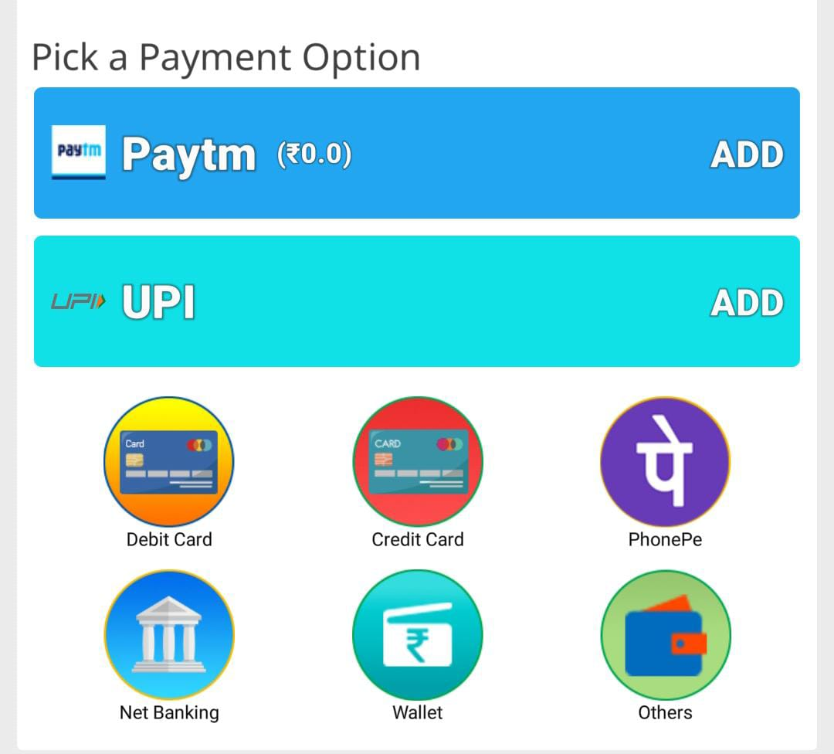

**Step 5:** Select the game and contest you want to play and enjoy Playing in Big Cash App.

(There is 17+ games in the Big Cash App including card games, casual games, and fantasy games.)

## How to enter game (example of Fruit Chop)

After adding cash in the Big Cash wallet, let us see how to enter in any of the game in Big Cash App. Game entry flow has been explained by the example of the Fruit Chop Game.

**Step 1:** Tap on the game icon that you want to play (here taking example of Fruit Chop game).

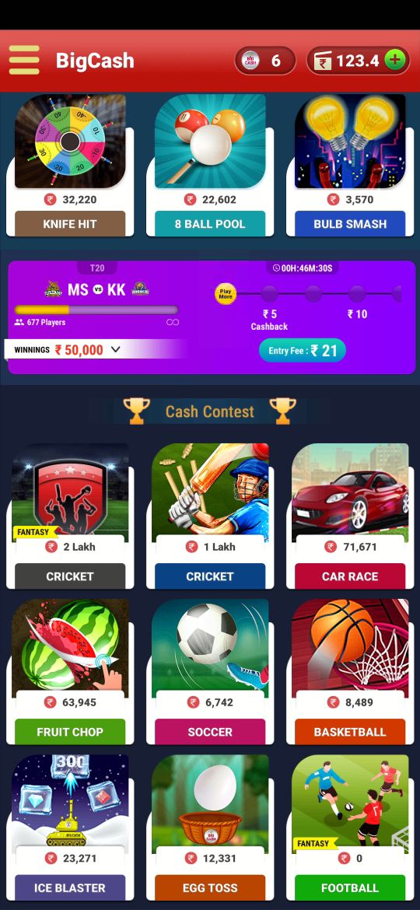

**Step 2:** Now it will be redirected to contest page. From contest page select the contest in which you want play.

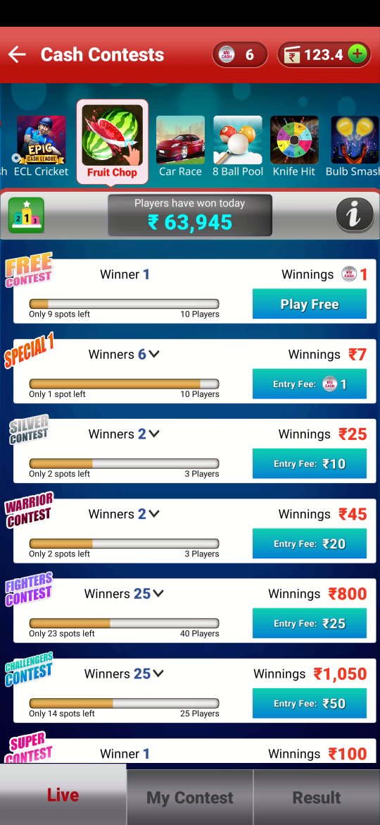

**Step 3:** If you do not have enough in the wallet, then you will be redirected to the add cash page in the app from where you can add amount in your wallet with the help of different modes for adding cash in the wallet (like debit/credit card, Google Pay, Ponape, Net banking, etc.) and after adding cash u will be redirected to contest page from where you can proceed to next step

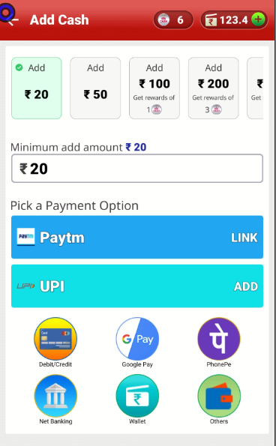

**Step 4:** If you have enough in your wallet, a popup will come of choose payment option, there chose the wallet and tap pay, the amount will be deducted from the wallet, and you will enter the game.

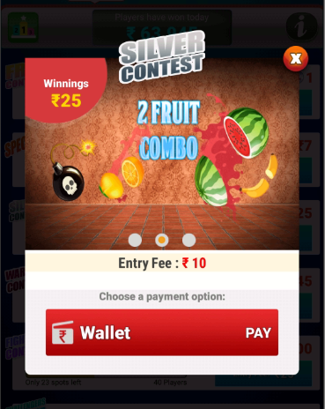

**Step 5**: if the game is being played for the first time, assets will get downloaded.

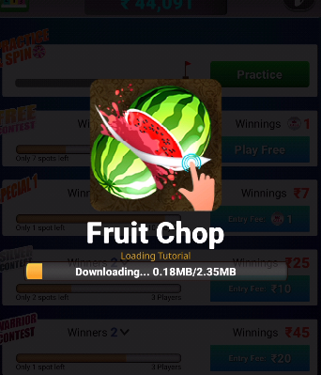

**Step 6:** how to play picture series will come, after going through how to play picture series, click on Play.

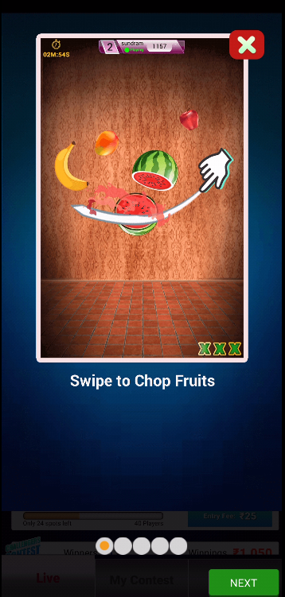 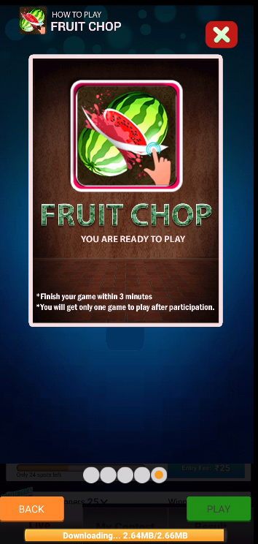

**Step 7:**  Now play the game and enjoy.

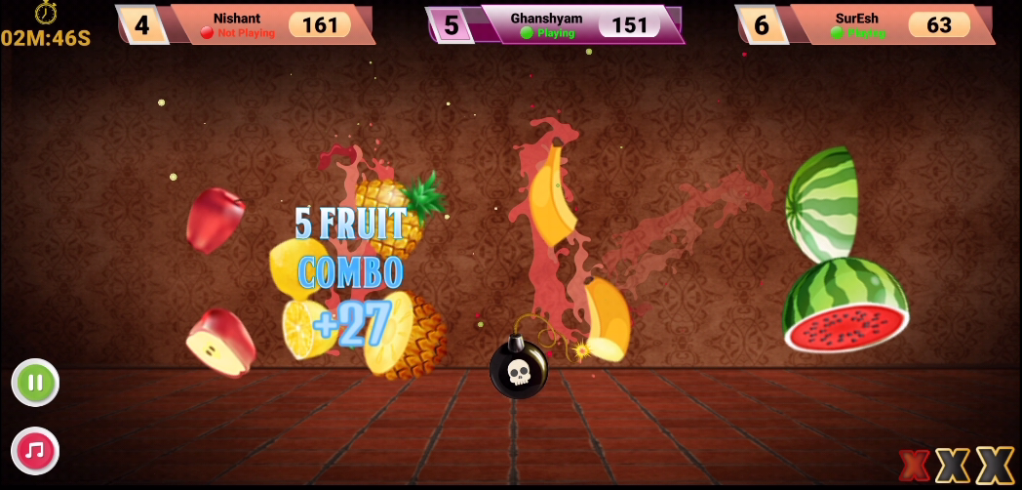

**Step 8:**  After completion of game, it will be redirected to leader board where results and winning can be seen.

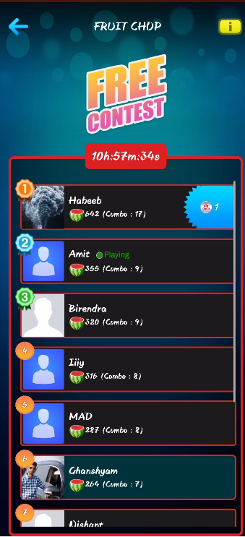

Finally, if you win the game then the winning amount will get credited to your Winning Wallet (Refer to Big Cash wallet section).

# Portal description

## Card Games

### Poker

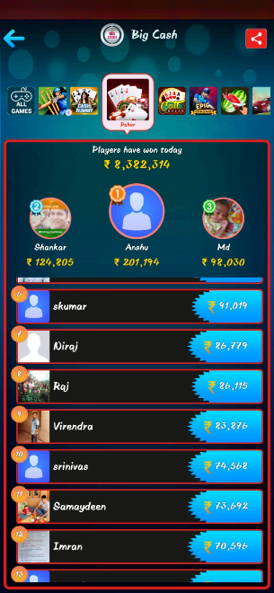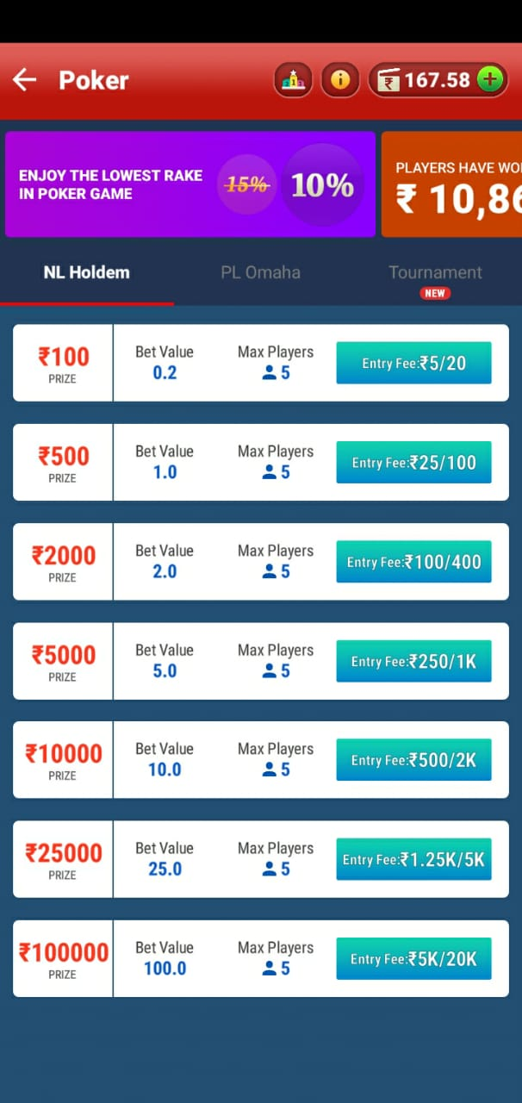

Minimum Bet value

Maximum winning prize

Maximum players on a table

Poker Type

minimum amount required to enter the table / maximum amount to be kept in table.

Leader board

Game Information

Amount the wallet.

### Leaderboard

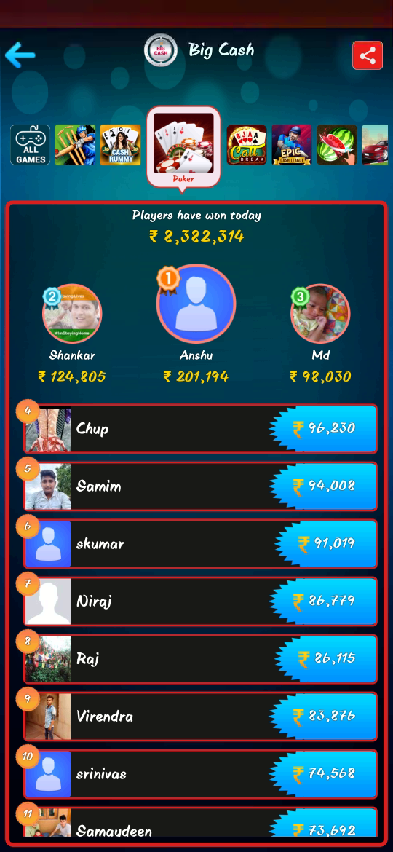

Name of the game

Total winning amount by all players for the particular game for current day

Winning Amount

Winner

Winning amount by the particular player

Rank

Share Icon

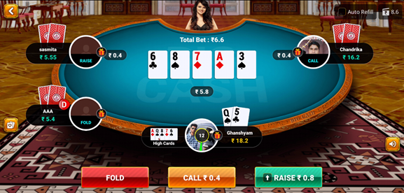

Turn Action

Sound on /off

Table balance

Hole cards

Community cards

Bet amount.

pot balance

wallet balance

Hand strength rank menu

### Rummy

Point value

winning prize

Entry fee

Rummy type

Max. players in a single table.

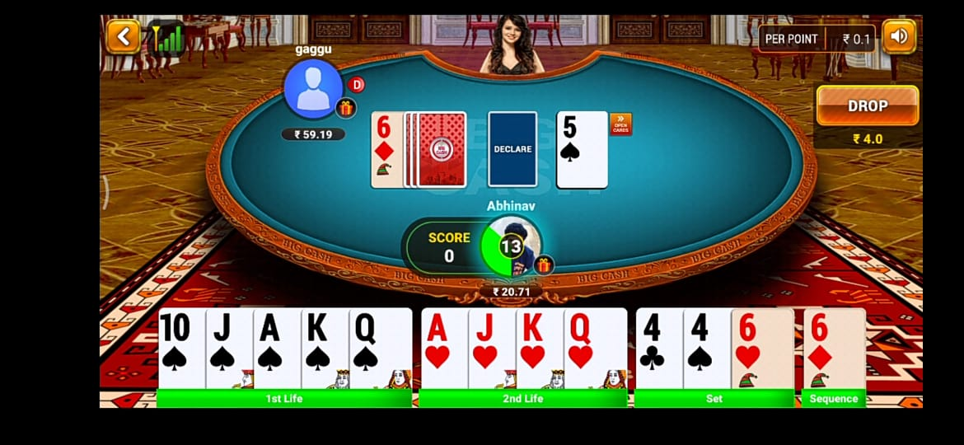

Drop option.

Score (score must be 0 in order to declare the cards before anyone else)

Joker

Hand Cards

Turn Timer

Deck Cards

Last Dropped Card

### Callbreak

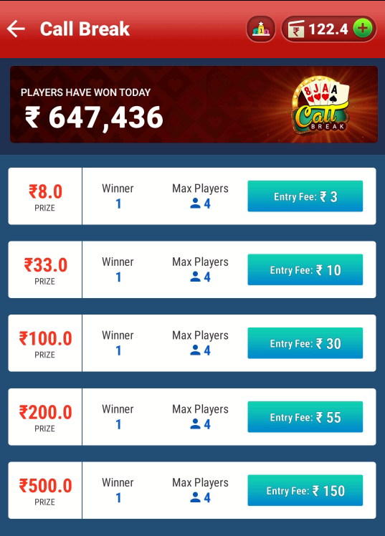

Winning prize

Total amount won by winners on current day.

Wallet balance

Leaderboard

Entry fee

Max. players allowed in a table.

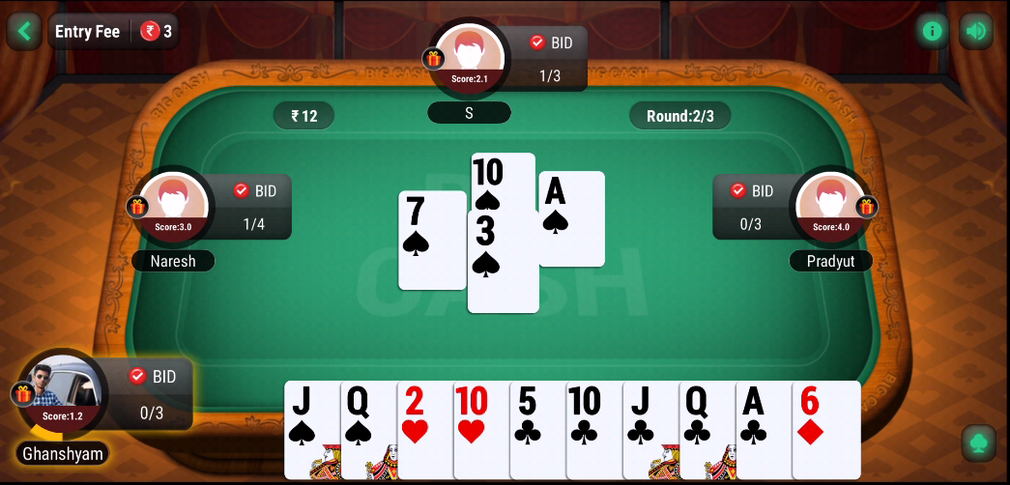

Hands taken out of hand called.

Scoreboard

Cards in hand

Round

Sound On/off

Table Information

## Casual games

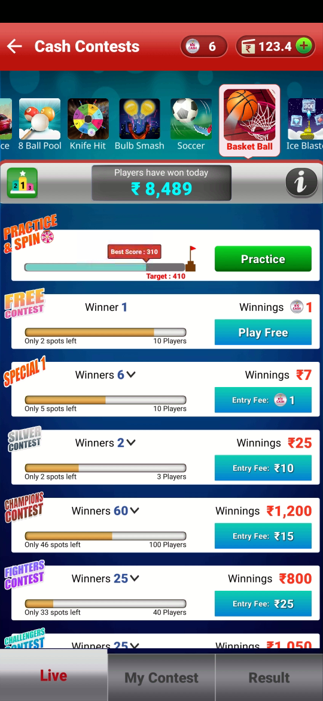

Max. no. of participant in one contest

Entry fee

Total winning prize

Leader board

Contest name

Total winners

Spots left for players to fill the contest limit.

Name of the game

Game information

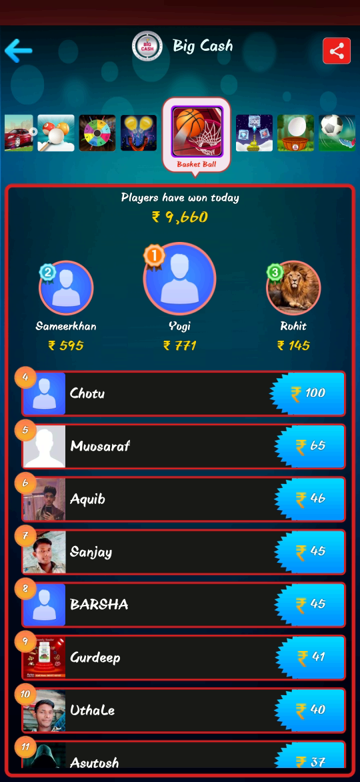

Rank

Share Icon

Name of the game

Total winning amount by all players for the particular game for current day

Winning Amount

Winner

Winning amount by the particular player

## Fantasy Games

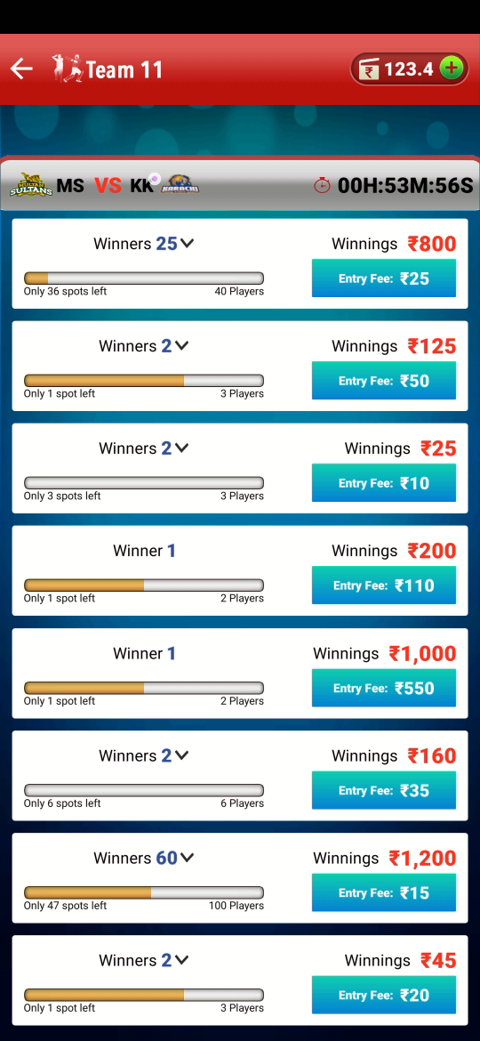

Deadline/ time left to start the match.

Spots left for the players to fill the contest.

Total winners to be awarded.

Match between

contest limit

Entry fee

Total winning prize

Wallet balance

# CHAPTER 2: CARD GAMES

CARD GAMES



POKER RUMMY CALL BREAK

NL HOLDEM POINT RUMMY

PL OMAHA POOL RUMMY

DEAL RUMMY

## Poker

### Objective

The objective of the poker is to earn money by capturing the pot which contains bets made by various players during the hand. A player wagers a bet in hopes that he has the best hand, or to give the impression that the holds a strong hand and thus convince his opponent to fold (abandon) their hands.

### How to enter Poker

**If you are not the registered user:**

* Go to [www.bigcash.live](http://www.bigcash.live)
* Click on download option and download the app.
* After installation, open the Big Cash App where user have to do the registration by entering the required credentials.
* Once the registration is done, the big cash app will open and will land you to the home page where all the games icon are displayed.

**In other case, if you are already the registered user:**

* Open the big cash app.
* Now user is on the homepage of Big Cash App where all the games icon are displayed.

**How to select contest and do payment and enter the game:**

* Tap on the poker game icon.
* Now it will be redirected to contest page.
* There user can select between NL holdem poker or PL Omaha poker on the bar just above the table entry fee section.

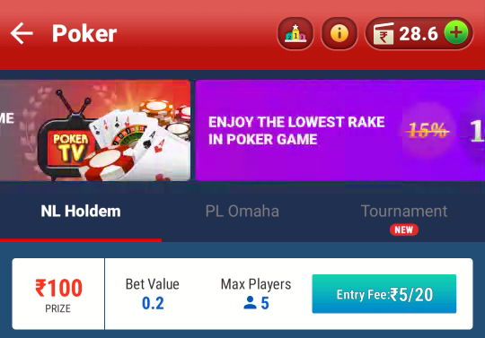

* From contest page select the contest in which you want play.
* If you don’t have sufficient amount in the wallet, then you will be redirected to the add cash page in the app from where you can add amount in your wallet with the help of different modes for adding cash in the wallet (like debit/credit card, Google Pay, PhonePe, Net banking, etc.) and after adding cash u will be redirected to contest page from where you can proceed to next step.
* If you have sufficient amount in your wallet, a popup will come of choose payment option, there chose the wallet and tap pay, the amount will be deducted from the wallet, and you will enter the game and the amount now will be shown as table balance.
* The table balance left with the user after completing the game will be automatically credited back in the wallet from where it has been deducted.

NOTE: only the winning or losing amount will be shown in the transaction history, the amount taken to table balance or amount left in table balance which will be credited back in wallet will not be shown in transaction history.

NOTE: the amount will always get deducted from unutilized wallet at first and if the sufficient amount is not present or partially present in the unutilized wallet then the rest amount which is requires will be deducted from winning wallet

### Turn Action

### Check

when a bet is matched and any user don’t want to bet more, user CHECK for the round to proceed. User can still bet later in the round.

#### Fold

When user do not want to play a round, user FOLD to forfeit that round. user can join the game on the next round.

#### Raise

when user want to increse the stake by betting more, user RAISE the bet to the desire amount.

#### call

When the previous player raises the bet, you CALL their raise to stay in the round.

### Turn Timer

#### Primary timer

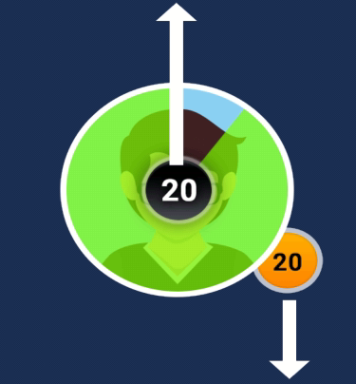The player has this timer to play each turn. This timer reset at every turn.

#### Secondary timer

This timer starts when primary timer expires. Secondary timer acts as a global timer. It is associate with table. Once expired it does not reset until player has started new session. this timer does not reset on every turn.

### NL Holdem

The minimum bet in No Limit Hold'em is the same as the size of the big blind, but players can always bet as much more as they want, up to all of their chips.

Minimum raise: In No Limit Hold'em, the raise amount must be at least as much as the previous bet or raise in the same round. As an example, if the first player to act bets ₹5 then the second player must raise a minimum of ₹5 (total bet of ₹10).

Maximum raise: The size of your stack (your chips on the table).

In No Limit Hold'em, there is no ‘cap’ on the number of raises allowed.

#### Contest Table

|  |  |  |  |
| --- | --- | --- | --- |
| Entry fee (Rs.) | Bet value (Rs.) | Prize (Rs.) | Platform fee |
| 5/20 | 0.2 | 100 | 10% |
| 25/100 | 1.0 | 500 | 10% |
| 100/400 | 2.0 | 2000 | 10% |
| 250/1000 | 5.0 | 5000 | 10% |
| 500/2000 | 10.0 | 10000 | 10% |
| 1.25K/5K | 25.0 | 25000 | 10% |
| 5K/20K | 100.0 | 100000 | 10% |



Minimum Bet value

Maximum winning prize

Maximum players on a table

Poker Type

minimum amount required to enter the table / maximum amount to be kept in table.

Leader board

Game Information

Amount the wallet.

### Leaderboard



Name of the game

Total winning amount by all players for the particular game for current day

Winning Amount

Winner

Winning amount by the particular player

Rank

Share Icon

### Game play

#### Blinds

A small Blind and Big Blind are fixed amount for a table which are posted by two players to the left of Dealer (D) respectively before any cards is dealt on the table. These are mandatory bets. Two cards (called the hole cards) are then dealt to each player.

#### PRE-FLOP

A round of betting takes place based on the Player’s cards where the bets can be called or raised by the players or the players can drop out (fold) from the game, starting from the player to the left of the Big Blind in clockwise direction. Each player has the following options:

#### Fold

Discard his 2-hole cards (the user will no longer be a part of this hand after this action and loses all rights to contend from amount accumulated in the pot).

#### Call

Contribute an amount equivalent to the amount posted by the Big Blind.

#### Raise

Contribute of amount greater than the big blind (Restriction apply to the minimum amount user has to put extra to raise). When a Player chooses to raise, all the remaining players in the hands are required to at least match the raised amount to continue to be a part of hand (Exception: when a user does not have enough amount to raise or to match the raised amount, he can put his entire table balance in the pot and go “All in”.

This round of betting ends when all players who choose not to fold or go all-in, match the highest individual contribution to the pot of the player. (If player except one-fold, then the hand ends and all the money in the pot is awarded to the remaining player after any rake deductions that may apply). If 2 or more players remain in the hand after the end of this round, player move to Flop.

#### The Flop

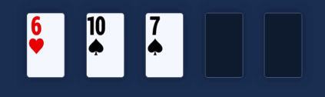Now, three cards are dealt face-up on the board. This is known as ‘the flop’. In Hold'em, the three cards on the flop are community cards, available to all players still in the hand. Betting on the flop begins with the active player immediately clockwise from the button. The betting options are similar to pre-flop, however if nobody has previously bet, players may opt to check, passing the action to the next active player clockwise.

#### The Turn

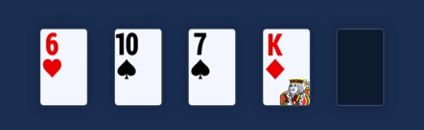When the betting action is completed for the flop round, the ‘turn’ is dealt face-up on the board. The turn is the fourth community card in Hold'em (and is sometimes also called ‘Fourth Street’). Another round of betting ensues, beginning with the active player immediately clockwise from the button.

#### The River

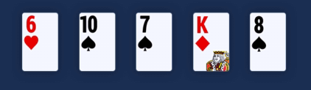When betting action is completed for the turn round, the ‘river’ or ‘Fifth Street’ is dealt face-up on the board. The river is the fifth and final community card in a Hold'em game. Betting again begins with the active player immediately clockwise from the button, and the same betting rules apply as they do for the flop and turn, as explained above.

#### The Showdown

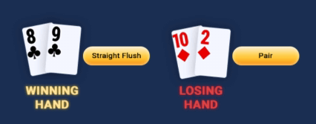If there is more than one remaining player when the final betting round is complete, the last person to bet or raise shows their cards, unless there was no bet on the final round in which case the player immediately clockwise from the button shows their cards first. The player with the best five-card poker hand wins the pot. In the event of identical hands, the pot will be equally divided between the players with the best hands. Hold'em rules state that all suits are equal.

### PL Omaha

The minimum bet in Pot Limit Omaha is the same as the size of the big blind, but players can always bet up to the size of the pot.

Minimum raise: The raise amount must be at least as much as the previous bet or raise in the same round. As an example, if the first player to act bets ₹5 then the second player must raise a minimum of ₹5 (total bet of ₹10).

Maximum raise: The size of the pot, which is defined as the total of the active pot, plus all bets on the table, plus the amount the active player must first call before raising.

Example: If the size of the pot is ₹100, and there is no previous action on a particular betting round, a player may bet a maximum of ₹100. After that bet, the action moves to the next player clockwise. That player can either fold, call ₹100, or raise any amount between the minimum (₹100 more) and the maximum. The maximum bet in this case is ₹400 - the raiser would first call ₹100, bringing the pot size to ₹300, and then raise ₹300 more, making a total bet of ₹400.

In Pot Limit Omaha, there is no ‘cap’ on the number of raises allowed.

#### Contest Table

|  |  |  |  |
| --- | --- | --- | --- |
| Entry fee (Rs.) | Bet value (Rs.) | Prize (Rs.) | Platform Fee |
| 25/100 | 0.5 | 500 | 10% |
| 50/200 | 1.0 | 1000 | 10% |
| 250/1000 | 5.0 | 5000 | 10% |
| 500/2000 | 10.0 | 10000 | 10% |

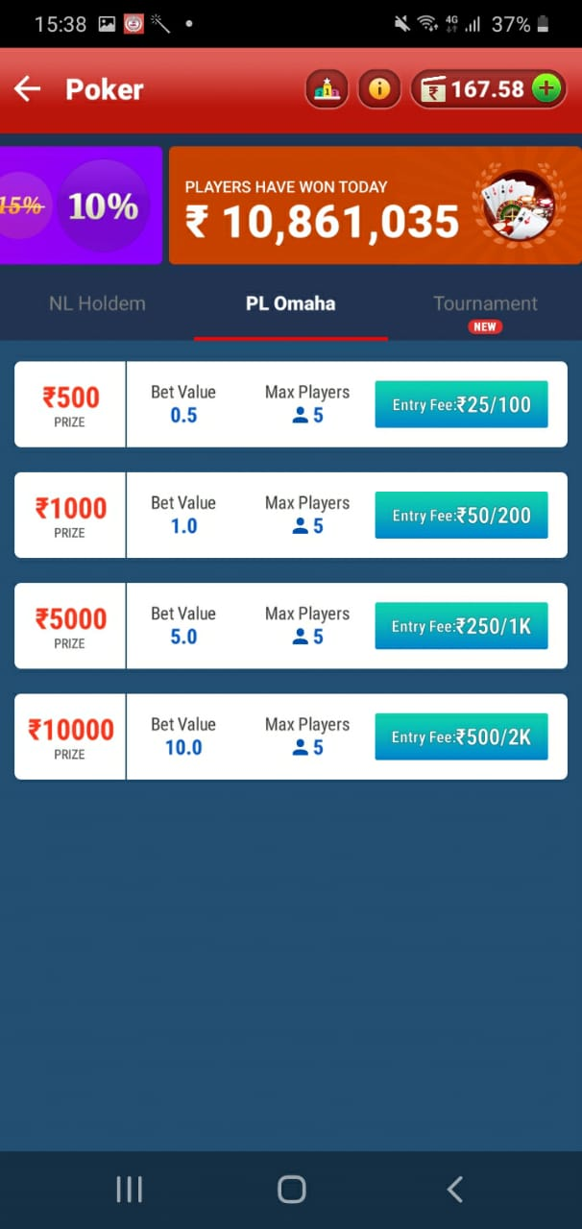

### Game Play

#### Basic Strategies

In Pot Limit Omaha games, the games are referred to by the size of their blinds (for example, a ₹1/₹2 Omaha game has a small blind of ₹1 and a big blind of ₹2).  
Betting then commences from the player to the left of the big blind.

In Fixed Limit Omaha games, the big blind is the same as the small bet, and the small blind is typically half of the size of the big blind but may be larger depending on the stakes.

For example, in a ₹2/₹4 Limit game the small blind is ₹1, and the big blind is ₹2.

Now, each player is dealt their four-hole cards. Betting action proceeds clockwise around the table, starting with the player ‘under the gun’ (immediately clockwise from the big blind).

#### Pre-Flop

After seeing his or her hole cards, each player now has the option to play his or her hand by calling or raising the big blind. The action begins to the left of the big blind, which is considered a ‘live’ bet on this round. That player has the option to fold, call or raise.

For example, if the big blind were ₹2, it would cost ₹2 to call, or at least ₹4 to raise. Action then proceeds clockwise around the table.

Betting continues on each betting round until all active players (who have not folded) have placed equal bets in the pot.

#### The Flop

After the first round of betting is complete, the ‘flop’ is dealt face-up on the board. The flop is the first three community cards available to all active players. Play begins with the active player immediately clockwise from the button. Another round of betting ensues. In Fixed Limit Omaha, all bets and raises occur in increments of the small bet (for example, ₹2 in a ₹2/₹4 game).

#### The Turn

When betting action is completed for the flop round, the ‘turn’ is dealt face-up on the board. The turn is the fourth community card in an Omaha game. Play begins with the active player immediately clockwise from the button. Another round of betting ensues. In Fixed Limit Omaha, bets and raises on the turn are in increments of the big bet (for example, ₹4 in a ₹2/₹4 game).

#### The River

When betting action is completed for the turn round, the ‘river’ is dealt face-up on the board. The river is the fifth and final community card in Omaha poker. The final round of betting begins with the active player immediately clockwise from the button.

#### The Showdown

If there is more than one remaining player when the final betting round is complete, the last person to bet or raise shows their cards, unless there was no bet on the final round in which case the player immediately clockwise from the button shows their cards first. The player with the best five-card hand wins the pot. Remember: in Omaha, players must use two and only two of their four-hole cards in combination with exactly three of the cards from the board. In the event of identical hands, the pot will be equally divided between the players with the best hands.

### How PL omaha differs from NL holdem

* 4-hole cards are dealt instead of 2 to each player.
* A player must always use cards from 4 cards to him/her and 3 cards from the 5 community cards to make best 5 cards.
* A limit is placed on the maximum amount that can be raised in the users turn. A user may raise any amount less than or equal to pot value. (Calculated after assuming that the user called the pot)

### Hand Strength

**1. Royal flush**  
A, K, Q, J, 10, all the same suit.

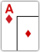 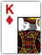 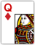 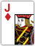 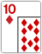

**2. Straight flush**  
Five cards in a sequence, all in the same suit.

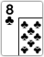 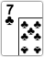 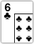 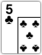 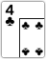  
**3. Four of a kind**  
All four cards of the same rank.

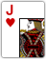  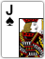 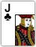 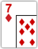

**4. Full house**  
Three of a kind with a pair.

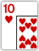  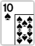 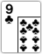 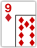

**5. Flush**  
Any five cards of the same suit, but not in a sequence.

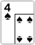  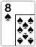 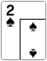 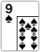

**6. Straight**  
Five cards in a sequence, but not of the same suit.

 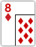 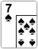 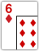 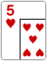

**7. Three of a kind**  
Three cards of the same rank.

   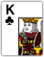 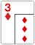

**8. Two pair**  
Two different pairs.

  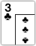  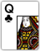

**9. Pair**  
Two cards of the same rank.

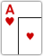    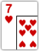

**10. High Card**  
When you haven't made any of the hands above, the highest card plays.  
In the example below, the jack plays as the highest card.

   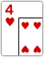 

### Example of a gameplay

In a table of entry fee of Rs.5/20 with bet value 0.2 minimum balance required in the wallet is Rs. 5.

#### Blinds

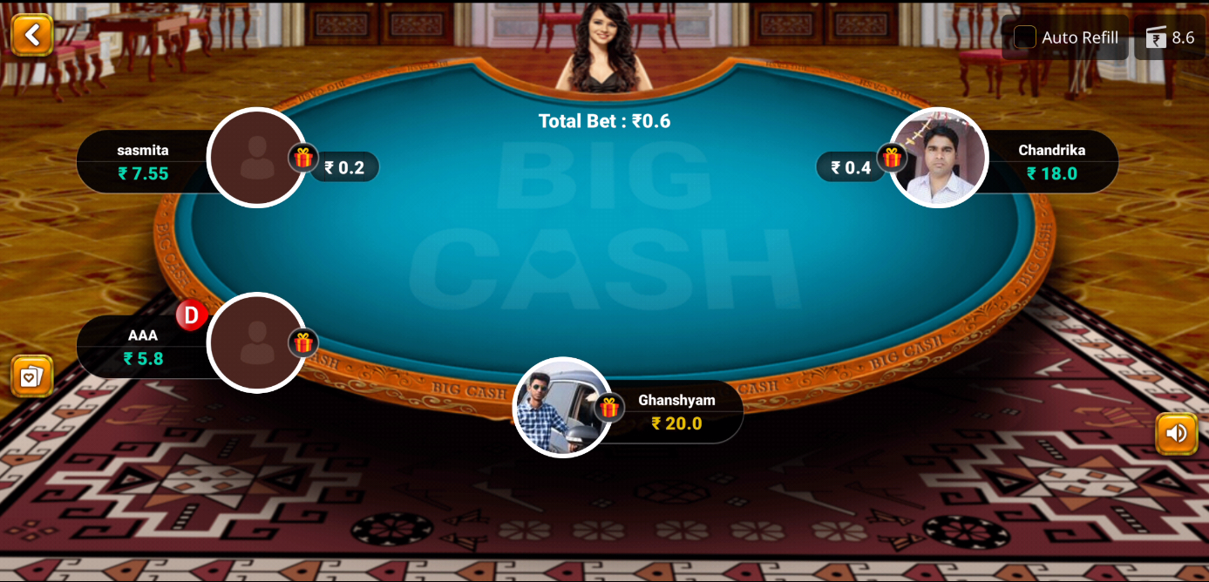

Hand strength rank menu

Table balance

Bet amount.

pot balance

wallet balance

Here the fixed bet amount of small blind is 0.2 and big blind is 0.4.

#### PRE-FLOP

Hole cards

Sound on/off

Auto refill to table balance from wallet

The first round of betting takes place right after all hole cards have been dealt to each player. The first player to act is the player to the left of the big blind, and this player then has three options:

**Call:** match the amount of the big blind (0.4 on this table)  
**Raise:** increase the bet within the specific limits of the game   
**Fold:** throw one's hand away

If a player chooses to fold, he or she is no longer eligible to win the current hand.

player can raise by any amount he wants up to the maximum that table balance allows, and betting all of your chips is deemed "all in" in this table minimum raise for this hand is 0.4 that means total bet will become 0.8 as 0.4+0.4

The players who follow have the same three options: call, raise or fold. In the case of raising, the minimum allotted amount for a raise must be equal to the original raise amount.

#### Flop

After the first preflop betting round has been completed, the second betting round takes place on the flop after the first three community cards have been dealt. In this betting round, and all that follow from now on, action starts with the first active player to the left of the dealer (D). Along with the options to bet, call, fold and raise, a player now has the option to check if no betting action has occurred prior. A check simply means to pass the action to the next player in the hand.

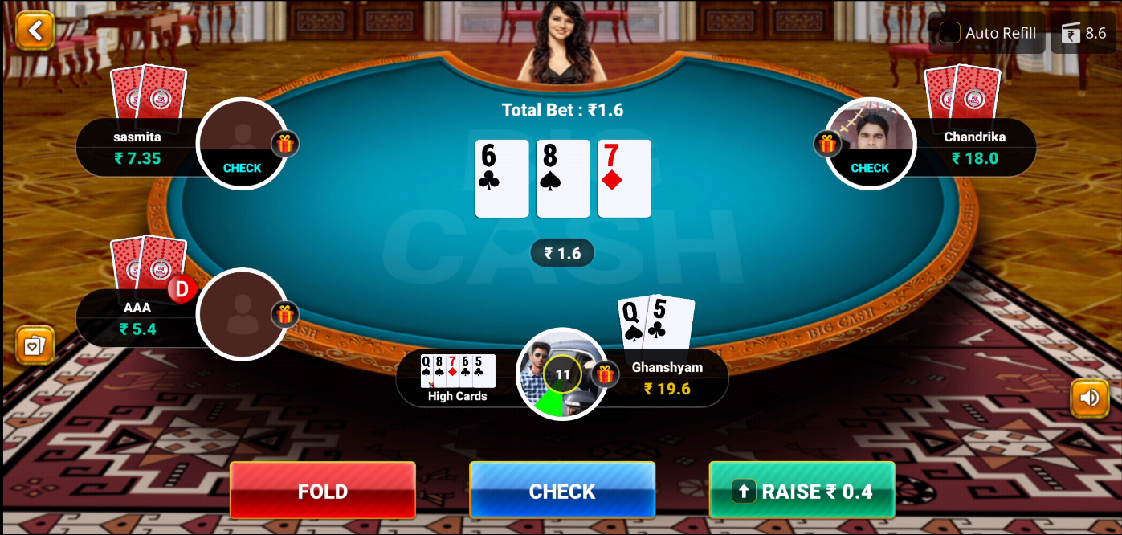

#### The Turn

The fourth community card, called the turn, is dealt face-up following all betting action on the flop. Once this has been completed, another round of betting occurs, similar to that on the previous street of play. Again, players have the option to bet, call, fold, raise and check.

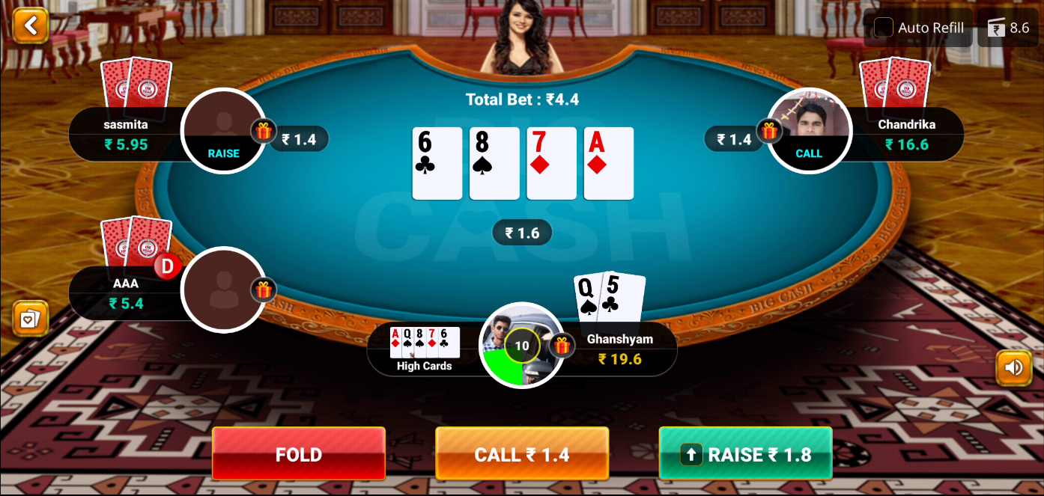

#### THE RIVER

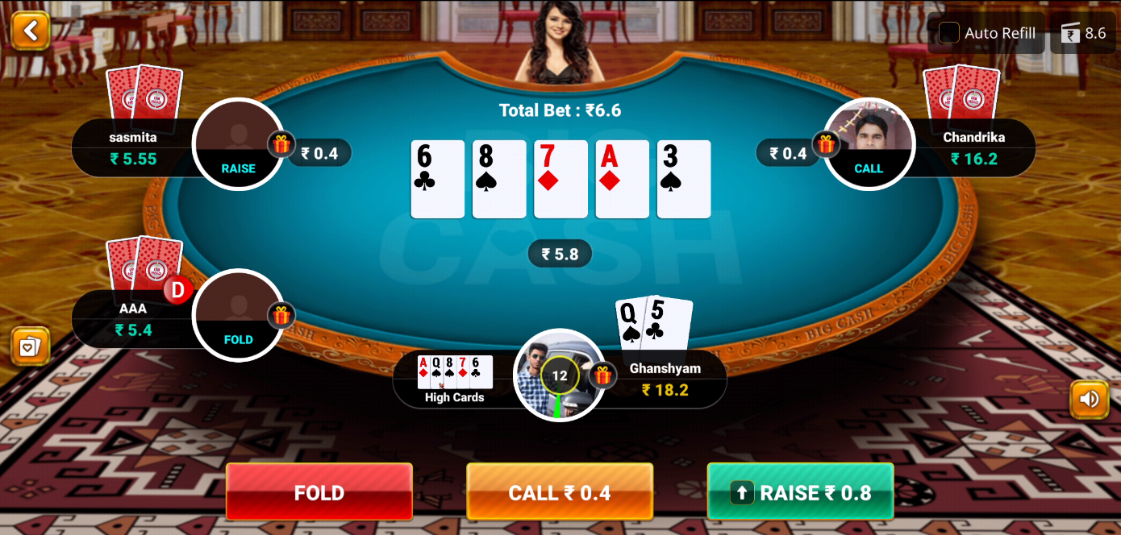The fifth community card, called the river, is dealt face-up following all betting action on the turn. Once this has been completed, another round of betting occurs, similar to that on the previous street of play. Again, players have the option to options to bet, call, fold, raise and check. After all betting action has been completed, the remaining players in the hand with hole cards now expose their holdings to determine a winner. This is called the showdown.

#### Showdown

The remaining players open their hole cards, and with the assistance of the dealer, a winning hand is determined. The player with the best combination of five cards will win the pot.

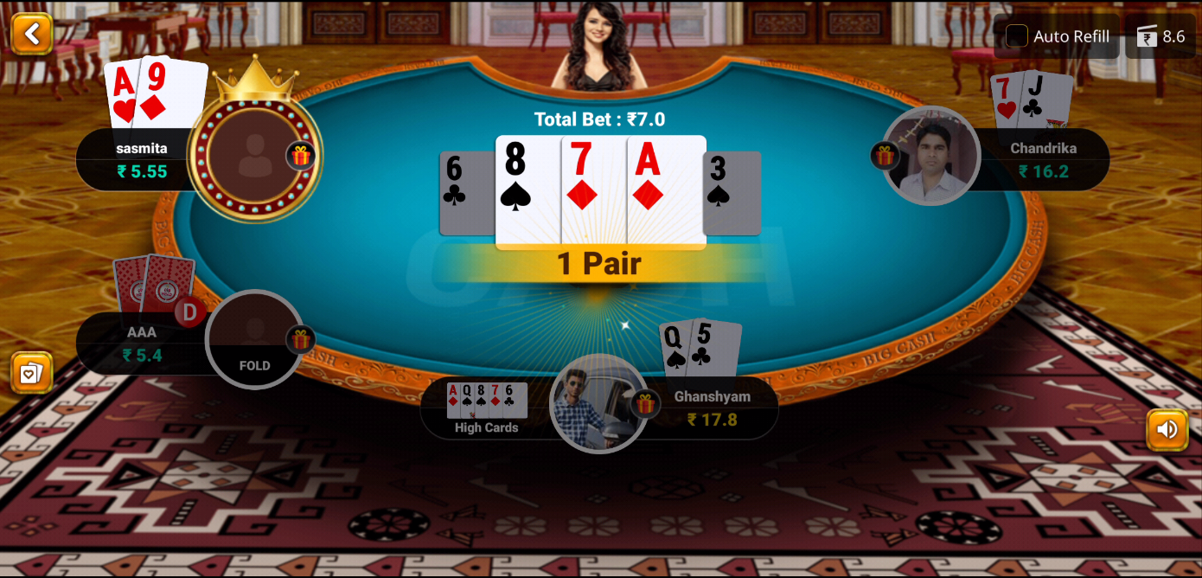

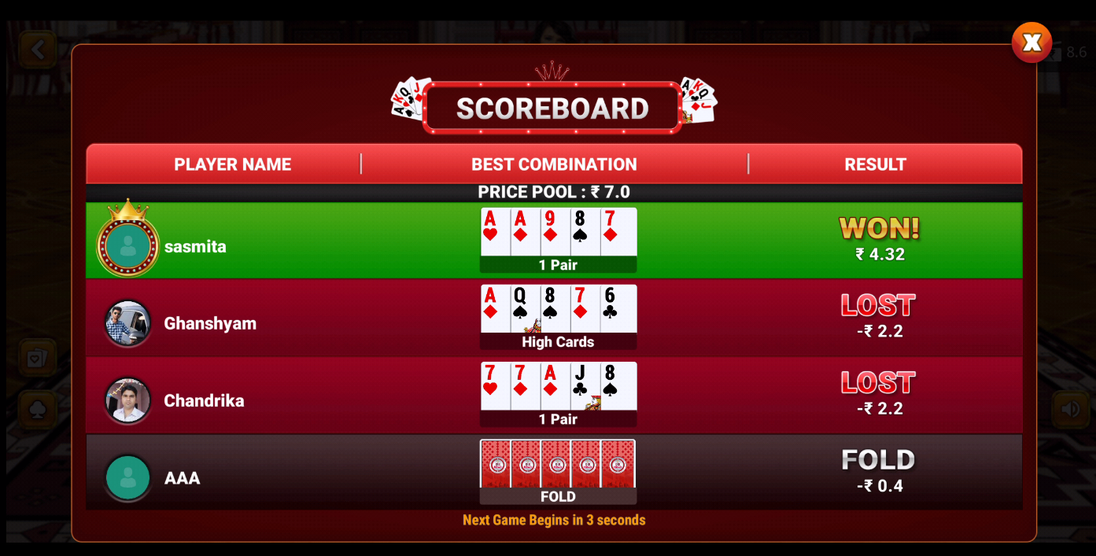

NOTE: if the table balance of the user is low then he/she can add cash in their table balance from wallet (unutilized or winning) balance in between the rounds.

Then Next round will be dealt automatically after 10 seconds. if user don’t want to play next round he can simply exit from the game.

### Winning prize Calculation

The winner gets the winning prize accordingly:

winning prize= 2* total bet amount of winner – bet value of the table

The winning amount of the winner is then credited to the winning wallet of BigCash.

### Terms and condition

The player must be at least 18 years of age to play poker in big cash.

# Call Break

Call Break game is a card game that is popular in India and Nepal. It is a strategy game of tricks, trumps, and bidding, and is played among four players. Call break is played with 52 cards distributed among four players, dealing one card at a time. The direction of the play is counterclockwise. Call break game starts with picking a dealer who distributes the cards.

## How to Enter in Call Break game

**If you are not the registered user:**

* Go to [www.bigcash.live](http://www.bigcash.live)
* Click on download option and download the app.
* After installation, open the Big Cash App where user have to do the registration by entering the required credentials.
* Once the registration is done, the big cash app will open and will land you to the home page where all the games icon are displayed.

**In other case, if you are already the registered user:**

* Open the big cash app.
* Now you are on the homepage of Big Cash App where all the games icon are displayed.

**How to select contest and do payment and enter the game:**

* Tap on the call break game icon.
* Now it will be redirected to contest page.
* From contest page select the contest in which you want play.
* If you don’t have sufficient amount in the wallet, then you will be redirected to the add cash page in the app from where you can add amount in your wallet with the help of different modes for adding cash in the wallet (like debit/credit card, Google Pay, PhonePe, Net banking, etc.) and after adding cash u will be redirected to contest page from where you can proceed to next step.
* If you have sufficient amount in your wallet, a popup will come of choose payment option, there chose the wallet and tap pay, the amount will be deducted from the wallet, and you will enter the game.

NOTE: the amount will always get deducted from unutilized wallet at first and if the sufficient amount is not present or partially present in the unutilized wallet then the rest amount which is requires will be deducted from winning wallet

### Objective

The objective for each player in each game is to win the exact number or a number higher of the calls (bets) they called in the beginning. For example, if a player called 4 before the game started, then they will have to win 4 or 5 calls/bets in the game to win 4 points (points equal to their call). If they get less than four or more than five bets/calls, then they will score -4. The game has 3 rounds.

**Trump Suit:**Spade is the trump suit in every game. This doesn’t change in call break card games.

### Contests

|  |  |  |  |
| --- | --- | --- | --- |
| Entry Fee (Rs.) | Total players | Winning Prize (Rs.) | Platform Fee |
| 3 | 4 | 8 | Rs.4 |
| 10 | 4 | 33 | Rs.7 |
| 30 | 4 | 100 | Rs.20 |
| 55 | 4 | 200 | Rs.20 |
| 150 | 4 | 500 | Rs.100 |

Note: There will be only one will and the only winner will get winning prize



Entry fee

Max. players allowed in a table.

Winning prize

Total amount won by winners on current day.

Leaderboard

Wallet balance

### Game play

#### The Call

Calling begins with the player sitting on the right side of the dealer and it continues anti-clockwise. Each player calls a number (minimum 1). This number corresponds to the number of bids/calls a player predicts to win in a game. Therefore, the maximum number that can be called is 13.

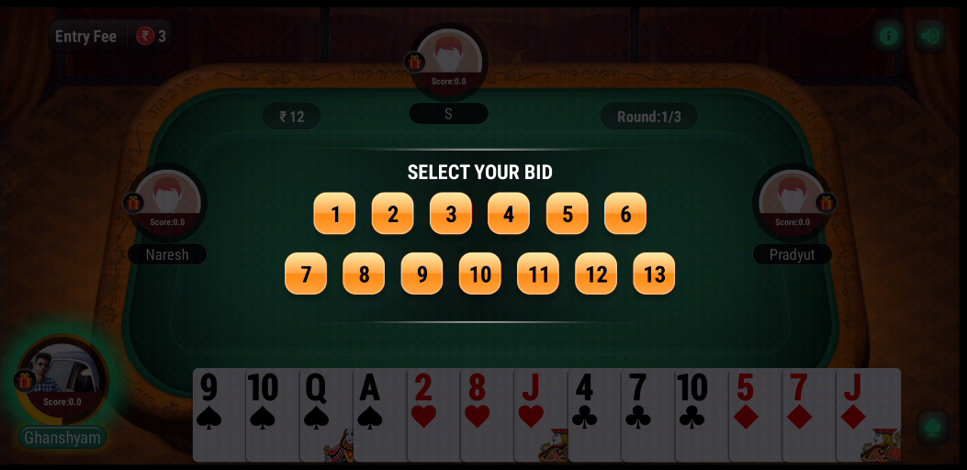

The player to the right of the dealer leads the first bet with any card of their choice. The players after that can top previous cards by throwing a higher card of the same suit (the suit of the lead card). If a player doesn’t have a higher card of that suit, they can throw a smaller card, too. Alternatively, they can throw a trump card, i.e., any spade. A trump card of any value tops a card of any rank from any other suit.

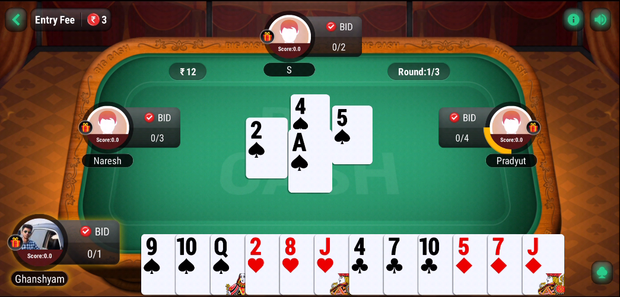

For example, the first player played 10 of hearts and the second player played queen of hearts to trump it, but the third player played 3 of spades to top the cards before, as spade is the trump suit. A trump card can be topped by another trump card of a higher value, e.g., a 3 of spades can be topped by 4 of spades or higher.

If a player doesn’t have a lead suit card or a trump card, they can play any other card they wish, but they won’t win the bet or trick with it.

The player who wins starts the next bet.

### Evaluation of points in call break

When all the cards in each player’s hands are finished, that game is complete. Then the points of each player are evaluated depending upon the calls they made in the beginning of the game. Winning players get points equivalent to the calls they made. Losing players lose the number of points they called.

However, a player who calls 3 and gets 4 bits then the player gets +0.1 for every extra bits/calls he scores.

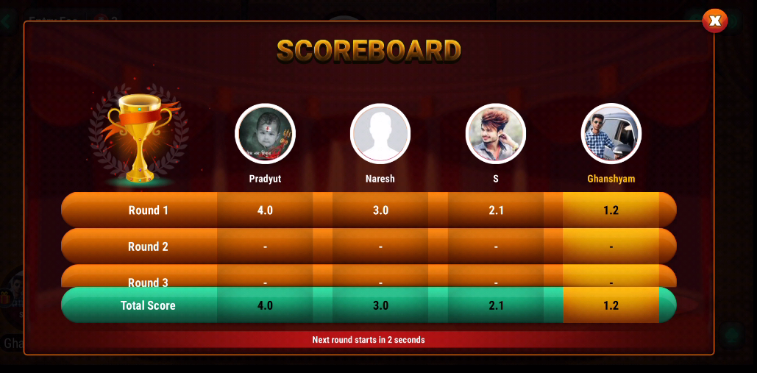

When a round or game is complete and its points are evaluated, the next game is started. There are 3 rounds, so the call break game continues till 3 rounds. When the game comes to end, the final scores of all the players from all the rounds are calculated to determine the winner.

### Other Call break card game Rules

* A player who has a card from the same suit as the lead card is not obligated to play it.
* A player who has no card from the lead suit but has a trump card is not obligated to play the trump card.

Note:

* If any player leaves or gets disconnected, then random cards will be auto discarded until the player re-joins the game.
* If two players have the same score, then prize will get equally distributed between them.
* If three players leave the table, then the last active player will be the winner.
* Any fraudulent activity may result in the permanent ban of the player Big Cash Account.

# RUMMY

## About

Indian Rummy is one of the most entertaining card games in the country. Indian Rummy is a game that resides in India's culture and has become an integral part of the online gaming industry. The classic rummy game is a complete package of fun, entertainment, and challenges that provides a refreshing gaming experience.

Big Cash provides the multiplayer environment which enables playing multiple rummy cash games with different players at the same time. Players can find various rummy online cash games running simultaneously on our platform.

## How to enter in rummy

**If you are not the registered user:**

* Go to [www.bigcash.live](http://www.bigcash.live)
* Click on download option and download the app.
* After installation, open the Big Cash App where user must do the registration by entering the required credentials.
* Once the registration is done, the big cash app will open and will land you to the home page where all the games icon are displayed.

**In other case if you are already the registered user:**

* Open the big cash app.
* Now user is on the homepage of Big Cash App where all the games icon are displayed.

**How to select contest and do payment and enter the game:**

* Tap on the Rummy game icon under trending section.
* Now it will be redirected to contest page.
* There user can select between Point Rummy, Pool Rummy, Deal Rummy, and tournaments by Big Cash on the bar just above the table entry fee section.

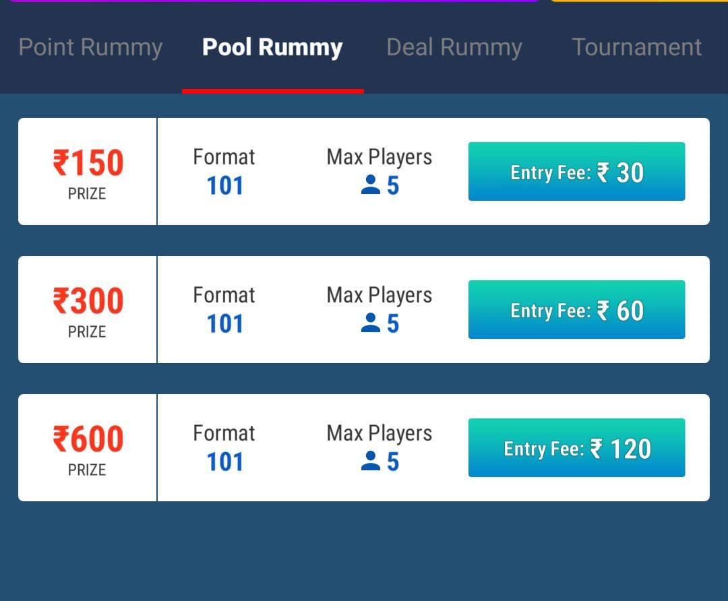

* From contest page select the contest in which you want play.
* If you don’t have enough in the wallet, then you will be redirected to the add cash page in the app from where you can add amount in your wallet with the help of different modes for adding cash in the wallet (like debit/credit card, Google Pay, PhonePe, Net banking, etc.) and after adding cash u will be redirected to contest page from where you can proceed to next step.
* If you have enough in your wallet, a popup will come of choose payment option, there chose the wallet and tap pay, the amount will be deducted from the wallet, and you will enter the game and the amount now will be shown as table balance.
* The table balance left with the user after completing the game will be automatically credited back in the wallet from where it has been deducted.

**NOTE:**

* Only the winning or losing amount will be shown in the transaction history, the amount taken to table balance or amount left in table balance which will be credited back in wallet will not be shown in transaction history.
* The amount will always get deducted from unutilized wallet at first and if enough is not present or partially present in the unutilized wallet then the rest amount which is requires will be deducted from winning wallet.

### Objective

The main objective of Rummy is to organize the 13 cards that each player gets invalid sets and sequences. To win the classic rummy games, you will have to make a minimum of two sequences, of which one must be a pure sequence while the rest can be any valid sequence sets. Without a pure sequence, an online Rummy declaration is said to be invalid.

### sequence

In Rummy, a sequence is formed if 3 or more consecutive cards of the same sequence are grouped together.

There are two types of sequence in online rummy:

* **Pure Sequence**
* **Impure Sequence**

Some important terminology and basic rules:

**Pure Sequence**: The grouping of 3 or more consecutive cards of the same suit without a joker.

**Impure Sequence**: These online Rummy sequences contain jokers.

**First Life**: The first pure sequence is called the First Life.

**Second Life**: The Second Life is a second pure sequence or the first impure sequence.

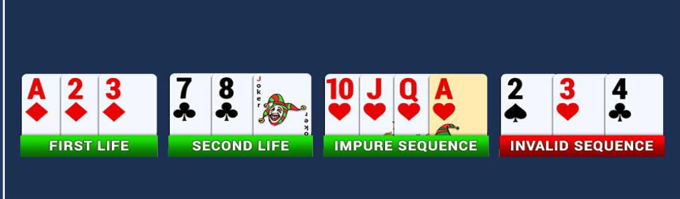

**Note:** Second life is not valid until the has First life.

### sets

**Sets in Indian Rummy**: Sets are a group of 3 or more cards with the same rank but different suits. Sets can contain Jokers.

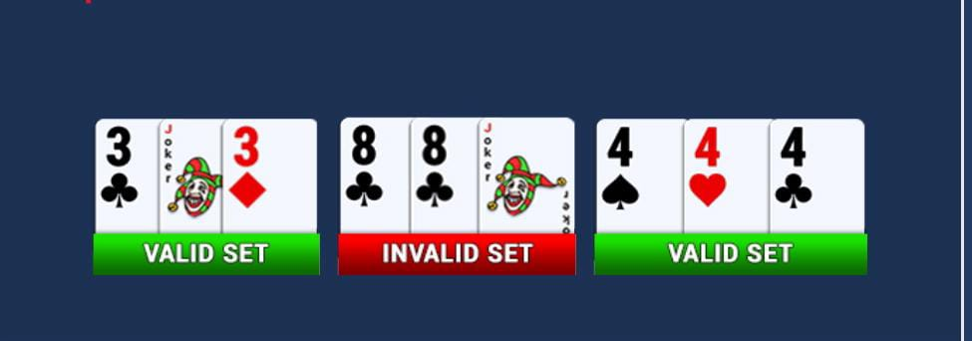

***Score:*** A player’s score is the sum of the value of all the cards that are not part of a valid sequence or set. The objective is to reduce your score to 0 by forming valid sequences and sets.

|  |  |
| --- | --- |
| Card | Value |
| King, Queen, Jack & Ace | 10 |
| Other cards in Deck | Value as per their rank |
| Joker | 0 |

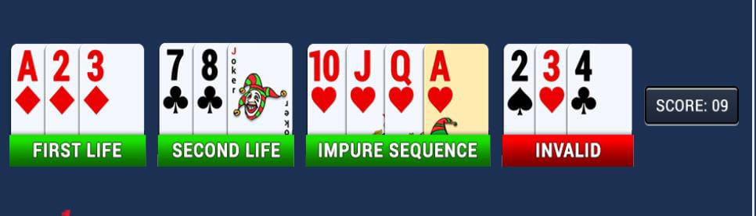

**NOTE:** Lower score is always better.

***Grouping of Cards:*** Tap on GROUP button or drag the cards as per your requirement manually.

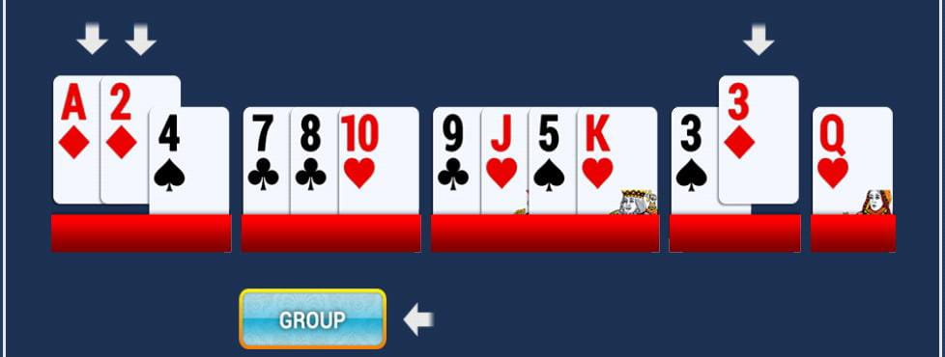

***Adding Cards:*** Tap on ADD HERE in the group you want to add or drag the cards as per your requirement to the desired group.

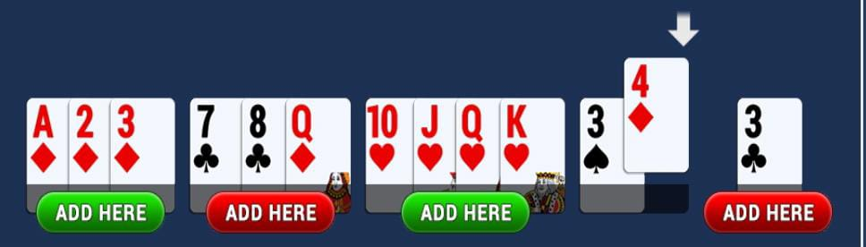

***Discard Cards:*** Tap on DISCARD BUTTON or drag the cards as per your requirement manually to the discard frame in the center of the table.

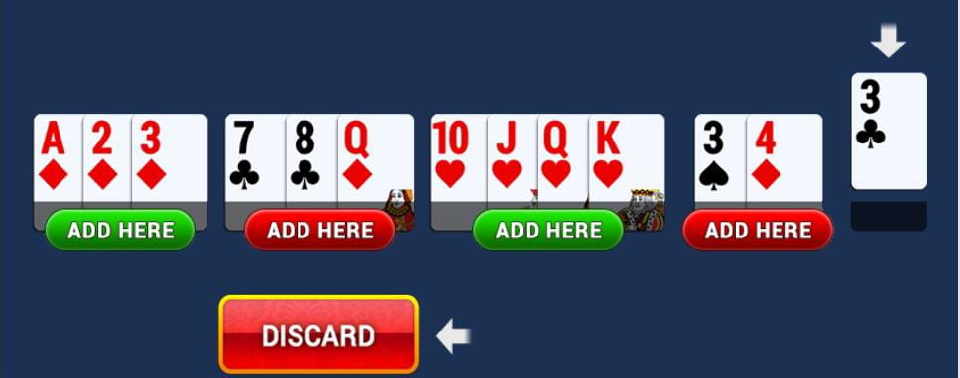

***Declare the game:*** Make sure all the 13 cards are arranged properly in the sequence and sets with at least 1 pure sequence and at last select the unwanted card to DECLARE instead of DISCARD.

Tap on the DECLARE button or drag the card to the DECLARE frame.

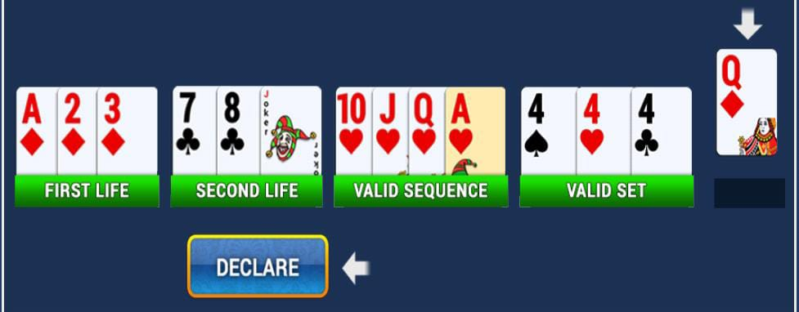

**Some Additional Rules**

* If player fails to pick up a card either from the open or closed deck before their turns out, the turn will switch to the next player.
* If player pick up a card but fails to discard any before their turn timer runs out, the card they picked up is discarded automatically.

**Our Rummy Games**

* Point Rummy
* Pool Rummy
* Deal Rummy

## Point rummy

### About

Point Rummy is the fastest and the basic among all, here game finishes in one round. Big Cash online rummy is played between 2 or 5 players with 1 or 2 standard decks of cards including 1 joker per deck.

### Entry fee, winning and platform charges.

|  |  |  |  |  |  |
| --- | --- | --- | --- | --- | --- |
| Entry  Fee (Rs.) | No. of  Players | Point  Value | Winning Amount (Rs.) | No. of  Winners | Platform  Fee |
| 4 to 800 | 2 to 5 | 0.1 to 10 | 16 to 4000 | 1 | 10% |

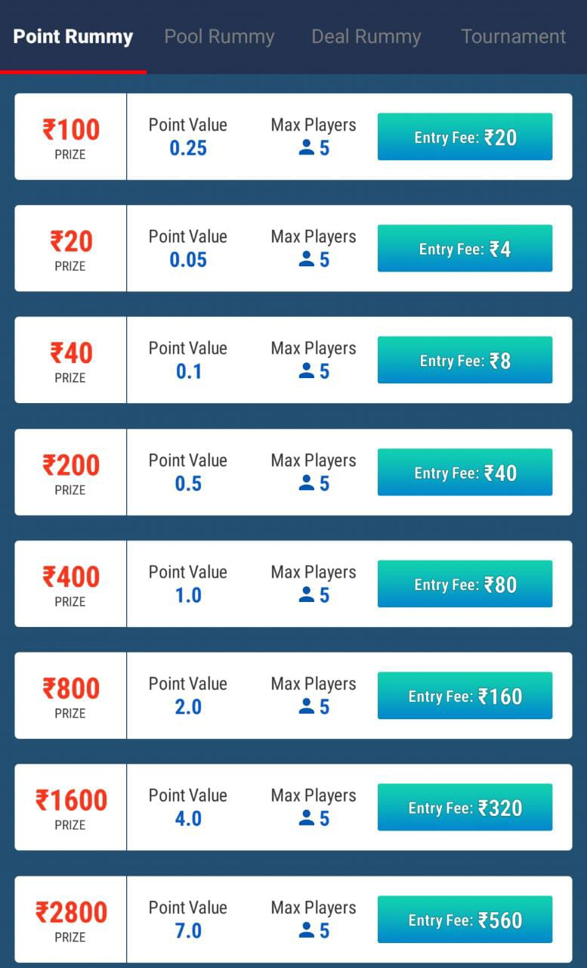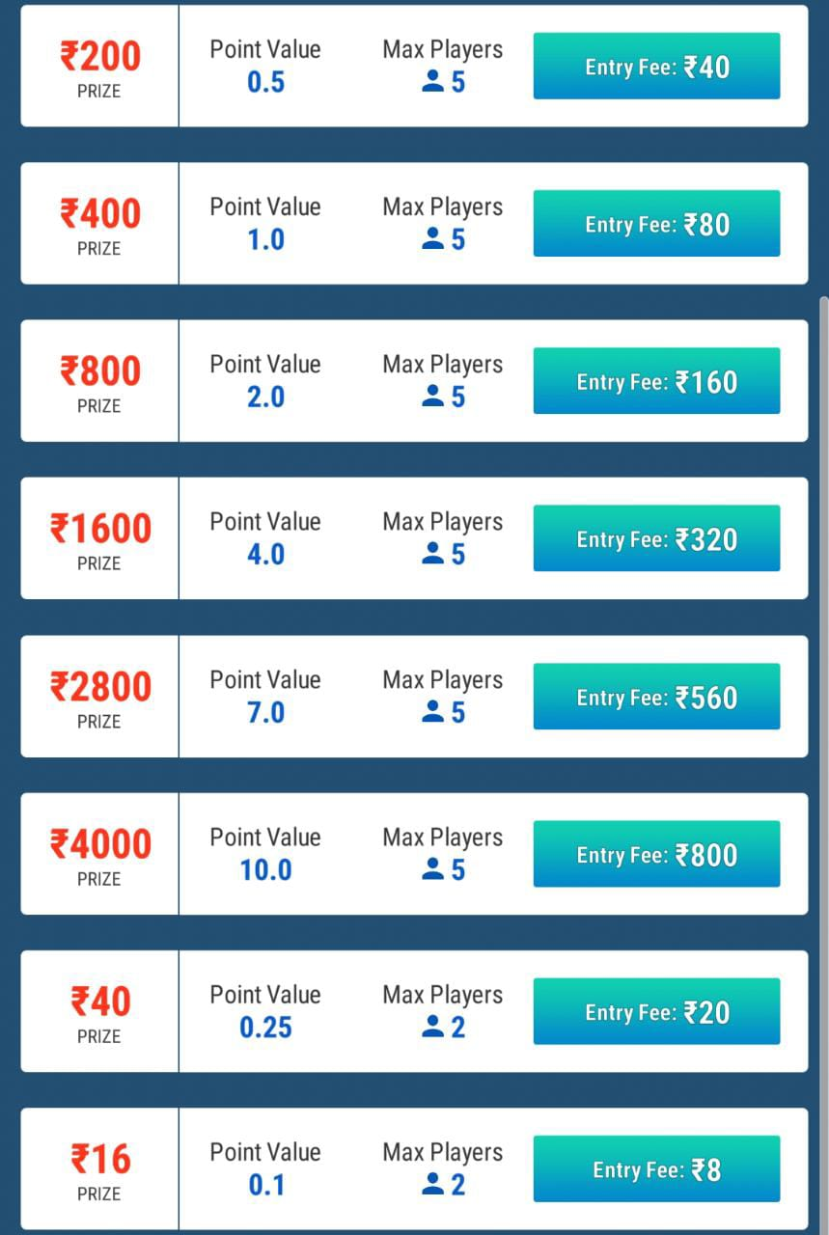

BIG Cash platform provides 16 different entry options in Point Rummy.

### Point Rummy Game Play

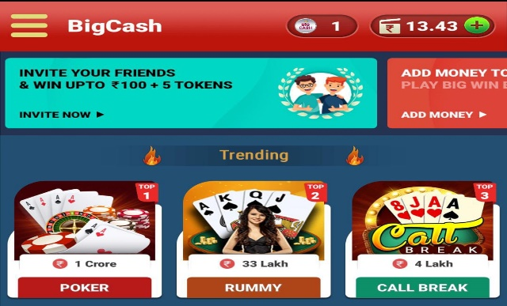**Step 1:** Open the Big Cash append click the Rummy game under Trending section.

**Step 2:** In this game play we will play the game having the point value 0.1, 2 players, with prize of Rs. 16 and entry fee of Rs. 8.

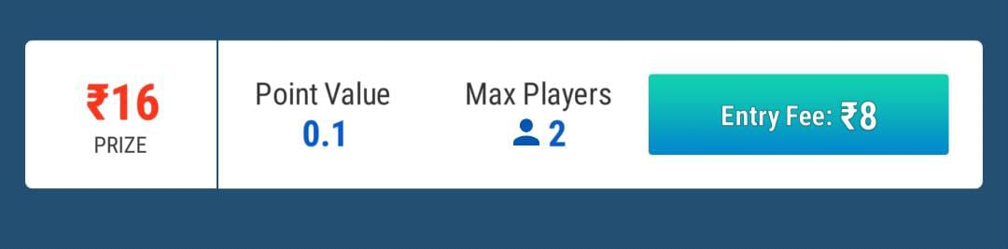

**Step 3:** Analyze your cards as they are distributed and start sorting them in sequence(pure/impure).

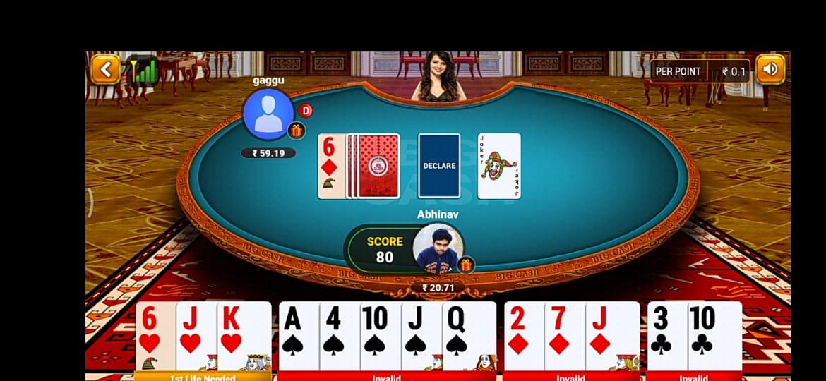

**Step 4:** Every player will simultaneously get the chance to pick the card from the open/close deck and discard the useless cards he/she already has to open deck. Once you complete your game then DECLARE your game by submitting the last useless card to the DECLARE section.

 **Pure sequence Pure sequence Invalid set Joker**

**Step 5:** Now when we declare the game, let’s see the point calculation. 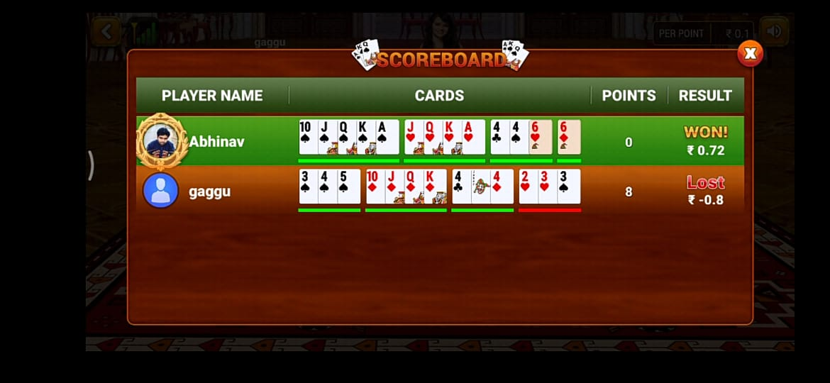

* + Here you can see clearly that the winner is having 0 point.
  + As mentioned in Step 2 the point value of the game was 0.1.
  + Calculation: Total points of opponent x point value

**8x0.1 =0.8**

**10% platform commission of 0.8 = 0.08**

**Winnings of the winner = 0.72.**

## Pool rummy

### About

Pool Rummy is played in two formats 101 and 201. At present Big Cash platform provides only 101 formats. The game is played among 5 players for a fixed entry fee. While playing Pool Rummy the players who hits 101 or 201 points are eliminated(looses) from the game and the player who remains till the last is declared as the winner of the game.

### Entry fee, winning and platform charges.

|  |  |  |  |  |  |
| --- | --- | --- | --- | --- | --- |
| Entry  Fee (Rs.) | No. of  Players | Point  Value | Winning Amount (Rs.) | No. of  Winners | Platform  Fee |
| 30 to 120 | 5 | 101 | 150 to 600 | 1 | 10% |



BIG Cash platform provides 3 different entry options in Pool Rummy.

## Deal Rummy

### About

Deal Rummy is different from its other variants. It is played among 2 to 5 players. The name itself describes the game as a fixed number of deals i.e., 2,3,4, or 6. Here each player in the game receives an equal number of scores at the start of every deal.

For example, in a game 2 deals the score of 160 and 3 deals the score of 240. Then the winner of the game is the player with the highest number of scores at the end of the game.

### Point Calculation in Deal Rummy.

Winning = Total Points of the opponents

For example, if there are 5 players and if Player 1 declares and the other player loses 5,10, 15, 30 points.

Then the score of PLAYER 1 (Winner) = 5+10+15+30 = 60 total.

### Entry fee, winning and platform charges.

|  |  |  |  |  |  |
| --- | --- | --- | --- | --- | --- |
| Entry  Fee (Rs.) | No. of  Players | Deal | Winning Amount (Rs.) | No. of  Winners | Platform  Fee |
| 15 to 100 | 5 | 3 | 30 to 200 | 1 | 10% |

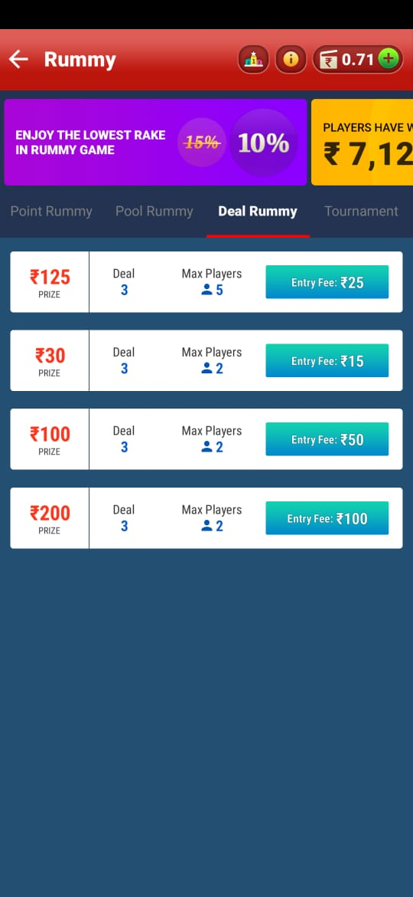

BIG Cash platform provides 4 different entry options in Deal Rummy.

### Special Terms of Big Cash Rummy

Along with the Mobile Games developed by Third party game Developers, BigCash Provide 13-card rummy to its users (BIGCASH RUMMY).

## TERMS for Big Cash Rummy

* Big Cash rummy is a standard 13-Card Game of rummy offered to it users. the standard rules of the game apply to BIG CASH Rummy.
* Users can participate in a Multiplayer contest or Tournament with other users without any restriction on participation, unless specified otherwise in the rules or the agreement.
* Collusion is strictly forbidden on BigCash rummy. In case we detect that you and other users are playing games and tournament forming a team it will result in cancellation of accounts of you and all such players who participated in forming a team. By accepting this term, you accept that you will not participate in forming a team, or by communicating with other players. In case you are found to be involved in such activities, we also reserve the right to freeze funds in your BigCash account and investigate further to ascertain the extent of undue benefit derived by you and such others and to cancel and close our account without any communication with you.
* Should we at any time have reasonable ground to suspect that you have or are using fraudulent means which are in violation of the terms of use herein, that you have or are using multiple ids which is in breach of terms of use, we have the right to debar you, suspend your account, prohibit your access to the website and withhold any prizes that you may have won, you hereby acknowledge and agree to the same.
* Apart from the Restricted states of Andhra Pradesh, Assam, Odisha, Nagaland, Tamil Nadu and Telangana, Big Cash Rummy currently not available to persons residing in the state of Kerala. we reserve the right to update the Restricted States for BigCash Rummy as required by Applicable Law or court Ruling.

## Game of Skills

* In providing the BigCash Rummy game of platform, BigCash takes great care to comply with all the central and state legislations in India to ensure that the Users are fully protected. BigCash rummy is carefully designed to comply with all applicable statutes and regulations in India.
* BigCash Rummy offered on the platform is a game of skill According to a 1967 Supreme Court Judgement in state of Andhra Pradesh v. K. Satyanarayana, in the game of game of rummy is a game of mere skill and playing rummy does not to gambling.
* Over the past few decades, various High Court have quoted the apex court’s decision and stated that law enforcement authorities can not interfere with the game of rummy played with stakes. In 1996, a three-judge bench of the Supreme Court affirmed its 1967 judgement and ruled those games involving substantial and preponderant degree of skill fall within the definition of games of mere skill.
* By virtue of its classification as a game of skill, the game of rummy does not violate the public Gambling Act,1867, and is excluded from the ambit of most state gaming legislation. However, users should note that owing to legislative/court restrictions in the restricted state and in the state of Kerala, hence residents of such restricted States and residents of Kerala are prohibited from participating in BigCash Rummy.

# CHAPTER 3: CASUAL GAMES

Casual games have very understandable gameplay and genre with very simple rules, shortest sessions and can be played with less learned skills than hardcore games. BigCash platform provides you variety of casual games like: Cricket Cash, Knife Hit, Car Race, Soccer, Basketball, Fruit Chop, Egg Toss, etc.

CASUAL GAMES

 PLAY OFF MULTIPLAYER

 EGG TOSS

 BULB SMASH ICE BLASTER

 BASKETBALL

 KNIFE HIT FRUIT CHOP

 SOCCER

 8 BALL POOL CAR RACE

CRICKET CASH



CANDY CASH BIG LUDO

FAST LUDO

# Play Off

## Bulb Smash

#### How to Enter in Bulb smash

**If you are not the registered user:**

* Go to [www.bigcash.live](http://www.bigcash.live)
* Click on download option and download the app.
* After installation, open the Big Cash App where user have to do the registration by entering the required credentials.
* Once the registration is done, the big cash app will open and will land you to the home page where all the games icon are displayed.

**In other case, if you are already the registered user:**

* Open the big cash app.
* Now you are on the homepage of Big Cash App where all the games icon are displayed.

**How to select contest and do payment and enter the game:**

* Tap on the bulb smash game icon in one vs one section.
* Now it will be redirected to contest page.
* From contest page select the contest in which you want play.
* If you don’t have sufficient amount in the wallet, then you will be redirected to the add cash page in the app from where you can add amount in your wallet with the help of different modes for adding cash in the wallet (like debit/credit card, Google Pay, PhonePe, Net banking, etc.) and after adding cash u will be redirected to contest page from where you can proceed to next step.
* If you have sufficient amount in your wallet, a popup will come of choose payment option, there chose the wallet and tap pay, the amount will be deducted from the wallet, and you will enter the game.

NOTE: the amount will always get deducted from unutilized wallet at first and if the sufficient amount is not present or partially present in the unutilized wallet then the rest amount which is requires will be deducted from winning wallet

#### Rules and Regulation

* When player enter in the game player will get random online user to play.
* Before starting the game, player will get 4 bulbs with different color (red, green, purple, and yellow) with score (10,20,30,40). Remember bulb score of each color, in every game bulb score changes.
* In game there would be 8 bulbs (2 bulbs of each color) moving.
* Player has to smash the bulb by hitting them and score.
* Player will get four chances for hitting the bulb.

NOTE: leader board icon is present on contest selection interface to see world ranking in that game.

#### Game play

* Total set in game is 4 and both the user will get 4 chance to smash bulbs.
* Player has to score higher points than opponent to win. Maximum winning points would be 100.
* Player will win/loss amount would be based on winning points. The player having higher point will win.
* In case of same winning points and same time match would be tie.

WARNING: If player play with multiple accounts or if player try any tricks player’s account will be blocked permanently.

|  |  |  |  |
| --- | --- | --- | --- |
| Contest | Entry Fee | Prize | Platform Fee |
| Delhi Club | Rs 5.00 | Rs 8.00 | Rs 2.00 |
| Goa Club | Rs 15.00 | Rs 27.00 | Rs 3.00 |
| Mumbai Club | Rs. 20.00 | Rs 32.00 | Rs 8.00 |

#### Contests

Entry fee

Contest Name

Leader board

Winning prize

Name of the game

## Knife Hit

This is one vs one game.

#### How to Enter in Knife hit

**If you are not the registered user:**

* Go to [www.bigcash.live](http://www.bigcash.live)
* Click on download option and download the app.
* After installation, open the Big Cash App where user have to do the registration by entering the required credentials.
* Once the registration is done, the big cash app will open and will land you to the home page where all the games icon are displayed.

**In other case, if you are already the registered user:**

* Open the big cash app.
* Now you are on the homepage of Big Cash App where all the games icon are displayed.

**How to select contest and do payment and enter the game:**

* Tap on the knife hit game icon in one vs one section.
* Now it will be redirected to contest page.
* From contest page select the contest in which you want play.
* If you don’t have sufficient amount in the wallet, then you will be redirected to the add cash page in the app from where you can add amount in your wallet with the help of different modes for adding cash in the wallet (like debit/credit card, Google Pay, PhonePe, Net banking, etc.) and after adding cash u will be redirected to contest page from where you can proceed to next step.
* If you have sufficient amount in your wallet, a popup will come of choose payment option, there chose the wallet and tap pay, the amount will be deducted from the wallet, and you will enter the game.

NOTE: the amount will always get deducted from unutilized wallet at first and if the sufficient amount is not present or partially present in the unutilized wallet then the rest amount which is requires will be deducted from winning wallet

#### Rules and Regulation

* When player enter in the game player will get random online user to play.
* On screen there will be a rotating circle
* Player need to throw all the 4 knives without hitting any of his/her knives or any existing knives on the circle.
* If player hit the bomb, game will be over.
* Player will get 4 turns to play.
* Player must earn points by hitting the circle section on which different points have been marked.

NOTE: leader board icon is present on contest selection interface to see world ranking in that game.

#### Game play

* To play Knife Hit player have tap the screen to throw a knife at a rotating circle.
* Player will get 4 turns to play.
* Player needs to throw all the knives without hitting any of his knives or any existing knives on the wood and the bomb.
* Player must earn points by hitting the circle section on which different points have been marked.
* Player will win/loss amount would be based on winning points. The player having higher point will win.
* In case of same winning points and same time match would be tie.

#### Contests

|  |  |  |  |
| --- | --- | --- | --- |
| Contest | Entry Fee | Prize | Platform Fee |
| Kerala Club | Rs 5.00 | Rs 8.00 | Rs 2.00 |
| Punjab Club | Rs 15.00 | Rs 27.00 | Rs 3.00 |
| Vegas Club | Rs. 20.00 | Rs 32.00 | Rs 8.00 |

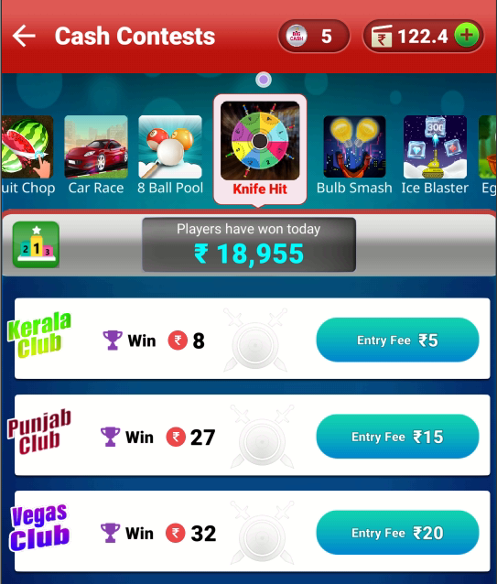NOTE: If player lose, player will lose entry fee as well

Leader board

Contest Name

Winning prize

Entry fees

Name of the game

## 8 Ball Pool

### About

8 Ball Pool is a very smooth and easy game, it comes under 1 vs 1 category. If the player pots the 8 ball wins the game. The main objective of 8 Ball Pool online is to put all your designated balls (either stripes or solids) in the pockets followed by the 8 ball (black ball).

#### Game Play

* Once you enter the 8 ball Pool game, you or your opponent will be asked to place the cue ball on or behind the head string on the Pool Table.
* Drag your cue stick in a circular direction to aim at the ball.
* You can use the strike point option on the cue ball to spin the ball when required.
* Pull down the cue stick to control the force and release it to take the shot.

#### Game Ends

* If the player pots the opponent’s ball.
* If the opponent hits the player’s ball.
* If the player pots cue ball.
* The ball player hit doesn’t touch the Pool Table rail.
* The cue ball doesn’t touch player’s desired ball.

### Graphical user interface, application Description automatically generatedContest, entry fee and winnings

|  |  |  |  |
| --- | --- | --- | --- |
| Contest | Entry Fee | Prize | Platform Fee |
| Delhi Club | Rs 5.00 | Rs 8.00 | Rs 2.00 |
| Goa Club | Rs 15.00 | Rs 27.00 | Rs 3.00 |
| Mumbai Club | Rs. 50.00 | Rs 90.00 | Rs 10.00 |
| Punjab Club | Rs. 100.00 | Rs 180.00 | Rs 20.00 |

## Candy Cash

### About

The main objective of the game is to clear as many as rows and columns of candies in the possible least moves with limited time. The player must achieve certain points within a certain move.

#### Game Play

* Once you enter the game and your game starts, you will be ranked based on your real-time score.
* Player can swipe candies left, right, up or down in order to make sequences
* Player can also make L or T shape of sequence of same color of candies and get a wrapped candy.

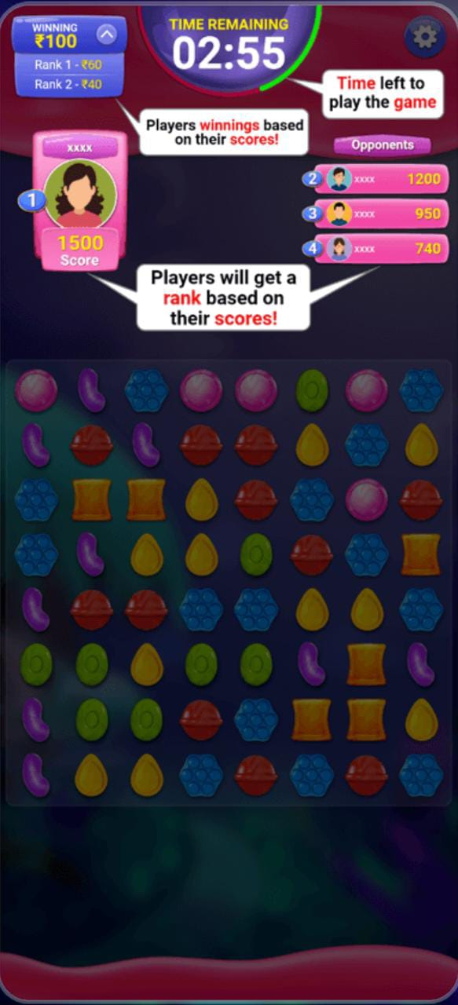 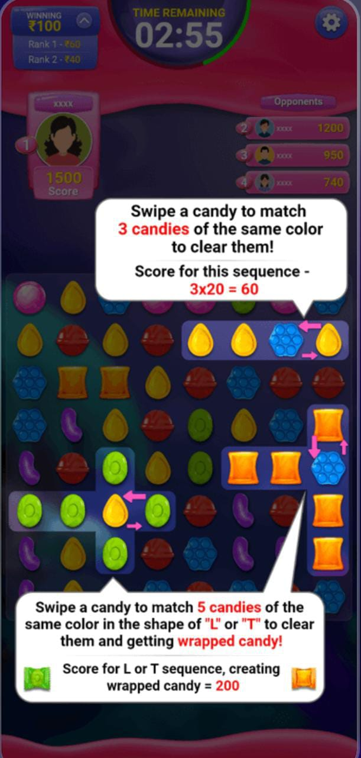

* Player can swipe candy to match 4 candies of same color and achieve a striped candy
* Player can swipe candy to match 5 candies of same color and achieve a candy bomb
* Player can swipe a striped candy and form a sequence of 3 or more candy which explode all the surrounding candies
* Player can swipe a striped and wrapped candy with each other to clear 3 columns and 3 rows.

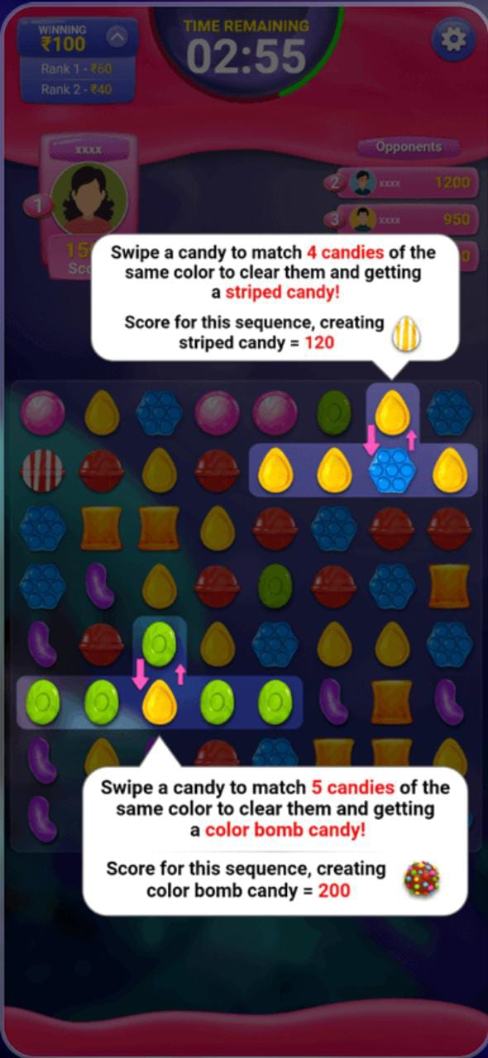 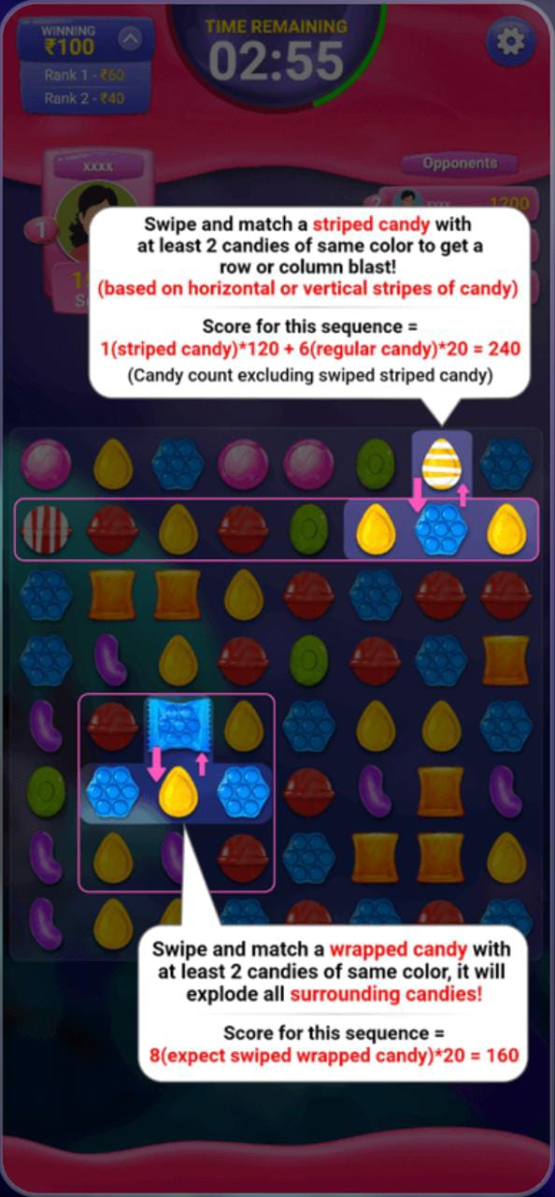 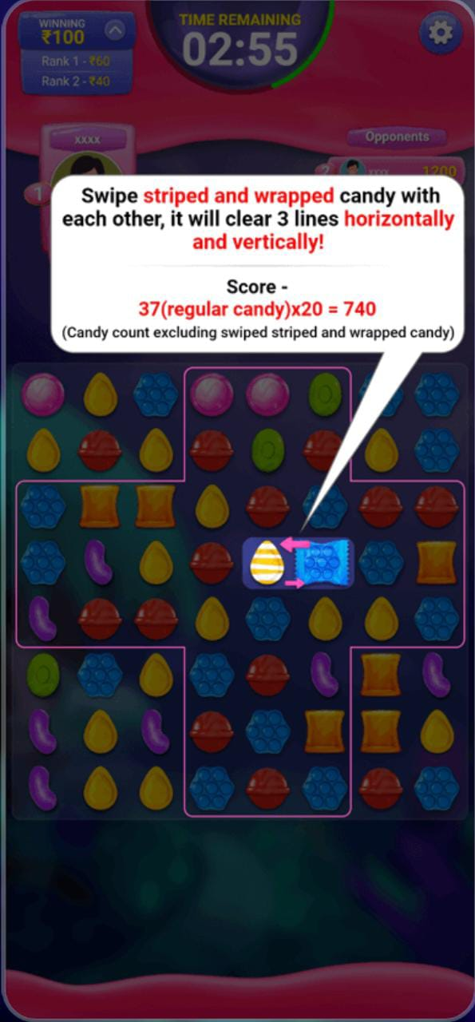

* Player can swipe a color bomb with a regular candy to eliminate all the candies on the board of same color
* If no valid sequence left on the board, a color bomb will be formed and placed

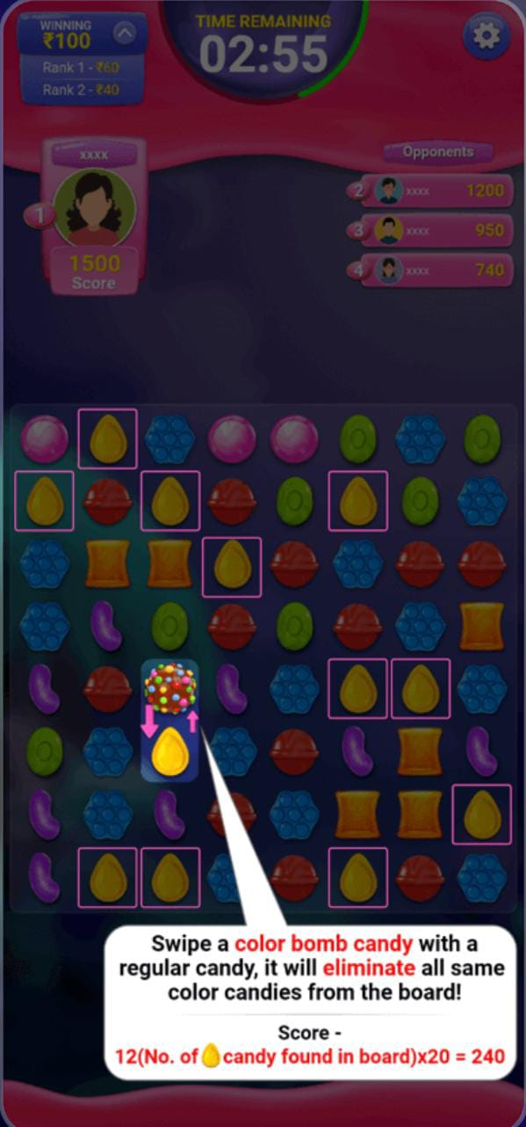 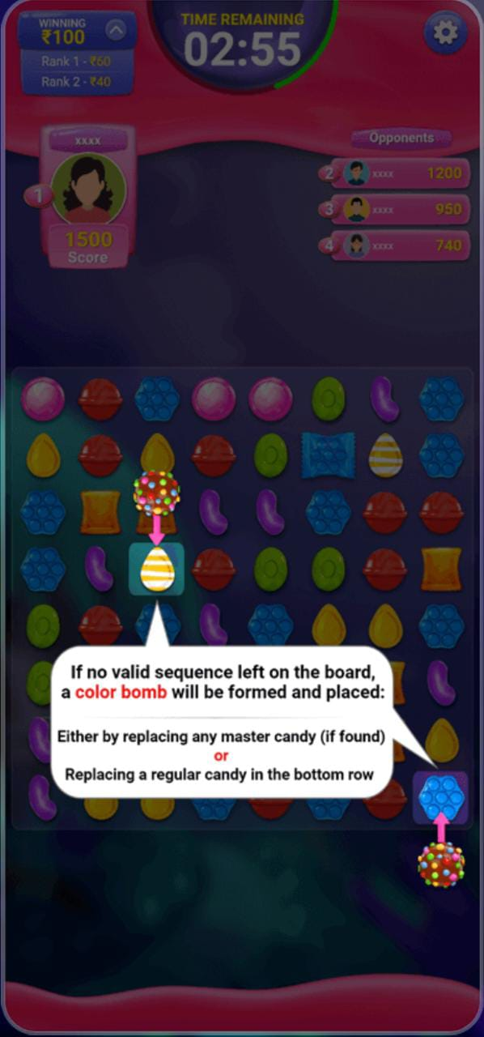

### Entry fee, winning and platform charges.

|  |  |  |  |  |
| --- | --- | --- | --- | --- |
| Entry  Fee (Rs.) | No. of  Players | Winning Amount (Rs.) | No. of  Winners | Platform  Fee |
| 3 to 12 | 2 | 5 to 21 | 1 | 12.5% to 16.6% |

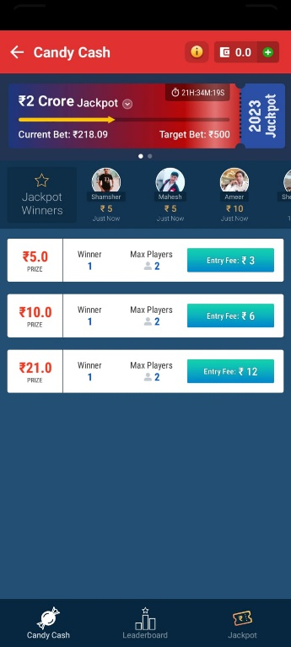

No. of Winners

No. of Players

Winning

Entry Fee

# MULTIPLAYER GAME

## Egg Toss

### How to Enter in Egg Toss

**If you are not the registered user:**

* Go to [www.bigcash.live](http://www.bigcash.live)
* Click on download option and download the app.
* After installation, open the Big Cash App where user have to do the registration by entering the required credentials.
* Once the registration is done, the big cash app will open and will land you to the home page where all the games icon are displayed.

**In other case, if you are already the registered user:**

* Open the big cash app.
* Now you are on the homepage of Big Cash App where all the games icon are displayed.

**How to select contest and do payment and enter the game:**

* Tap on the egg toss game icon in Casual games section.
* Now it will be redirected to contest page.
* From contest page select the contest in which you want play.
* If you don’t have sufficient amount in the wallet, then you will be redirected to the add cash page in the app from where you can add amount in your wallet with the help of different modes for adding cash in the wallet ( like debit/credit card, Google Pay, PhonePe, Net banking, etc. ) and after adding cash u will be redirected to contest page from where you can proceed to next step
* If you have sufficient amount in your wallet, a popup will come of choose payment option, there chose the wallet and tap pay, the amount will be deducted from the wallet, and you will enter the game.

NOTE: the amount will always get deducted from unutilized wallet at first and if the sufficient amount is not present or partially present in the unutilized wallet then the rest amount which is requires will be deducted from winning wallet

### Rules and Regulation

* Tap on egg to toss.
* On 1 successful toss, player will get 1 point.
* On collecting 1 diamond, player will get 3 points.
* On collecting 1 gem, player will get 2 points.
* Player will get 3 eggs and 3 minutes to score higher.
* Results will be declared within 30 minutes after league completion.
* If a smaller number of users participate in the particular contest (same as you) then your money will be refunded within 24 hours.
* Winning of BigCash token contest and practice will be credited in unutilized balance.

NOTE: On contest section interface there is “i” named button icon from where a play can see rules of the game any time, also leader board icon is present to see world ranking in that game.

### Game Play

* Tap on egg to toss and get the egg into next basket.
* Player will get 3 eggs and 3 minutes to score higher.
* collect diamonds and gems to score higher.
* Player wins if the score is highest among the rest player in that multiplayer game.

NOTE: you will get only one game to play after participation

### Contests

|  |  |  |  |  |  |  |
| --- | --- | --- | --- | --- | --- | --- |
| Contest | Total Entry (Spot) | Entry Fee | Total Winner | Total winning Prize | Prize Breakup | Platform Fee |
| SPECIAL 1 | 10 | 1 Big  Cash Token | 6 | Rs.7 | Rank 1: Rs 2.00  Rank 2: Rs 1.00 | - |
| SILVER | 3 | Rs 10.00 | 2 | Rs.25 | Rank 1: Rs 20.00  Rank 2: Rs 5.00 | Rs 5.00 |
| WARRIOR | 3 | Rs 20.00 | 2 | Rs.45 | Rank 1: Rs 40.00  Rank 2: Rs 5.00 | Rs 15.00 |
| CHAMPIONS | 100 | Rs. 15 | 60 | Rs.1200 | Rank 1: Rs 100.00  Rank 2: Rs 75.00  Rank 3: Rs 55.00  Rank 4: Rs 45.00  Rank 5: Rs 35.00  Rank 6-45: Rs 20.00  Rank 46-60: Rs 6.00 | Rs 300.00 |
| FIGHTERS | 40 | Rs 25.00 | 25 | Rs.800 | Rank 1: Rs 115.00  Rank 2: Rs 100.00  Rank 3: Rs 75.00  Rank 4: Rs 60.00  Rank 5: Rs 50.00  Rank 6-15: Rs 30.00  Rank 16-25: Rs 10.00 | Rs 200.00 |
| CHALLENGERS | 25 | Rs 50.00 | 25 | Rs.1050 | Rank 1: Rs 150.00  Rank 2: Rs 100.00  Rank 3: Rs 95.00  Rank 4: Rs 85.00  Rank 5: Rs 75.00  Rank 6-10: Rs 55.00  Rank 11-15: Rs 54.00  Rank 16-25: 1 Token | Rs 200.00 |
| SUPER | 2 | Rs 60.00 | 1 | Rs.100 | Rank 1: Rs 100.00 | Rs 20.00 |

* Practice & spin: In this a player can do practice free, after watching an ad., player will also get a spin wheel to earn different bonus like tokens, cash, or discounts coupons.
* Free Contest: Here player can play free and can win 1 token after scoring to rank 1. there will be one winner. In one multiplayer game 10 players can join.

NOTE: If player lose, player will lose entry fee as well

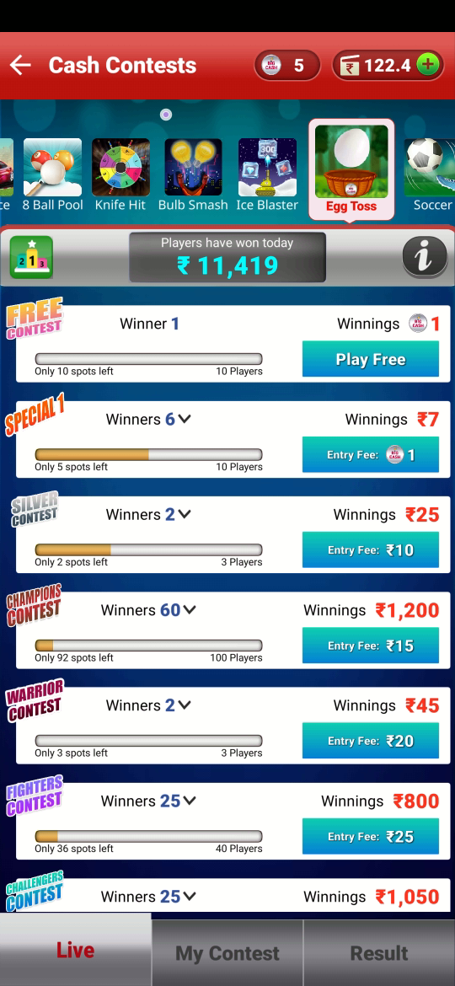

Total winners

Contest name

Leader board

Total winning prize

Entry fee

Max. no. of participant in one contest

Spots left for players to fill the contest limit.

Game information

Name of the game

## Ice Blaster

### How to Enter in Ice Blaster

**If you are not the registered user:**

* Go to [www.bigcash.live](http://www.bigcash.live)
* Click on download option and download the app.
* After installation, open the Big Cash App where user have to do the registration by entering the required credentials.
* Once the registration is done, the big cash app will open and will land you to the home page where all the games icon are displayed.

**In other case, if you are already the registered user:**

* Open the big cash app.
* Now you are on the homepage of Big Cash App where all the games icon are displayed.

**How to select contest and do payment and enter the game:**

* Tap on the ice blaster game icon in Casual games section which you want to play.
* Now it will be redirected to contest page.
* From contest page select the contest in which you want play.
* If you don’t have sufficient amount in the wallet, then you will be redirected to the add cash page in the app from where you can add amount in your wallet with the help of different modes for adding cash in the wallet ( like debit/credit card, Google Pay, PhonePe, Net banking, etc. ) and after adding cash u will be redirected to contest page from where you can proceed to next step
* If you have sufficient amount in your wallet, a popup will come of choose payment option, there chose the wallet and tap pay, the amount will be deducted from the wallet, and you will enter the game.

NOTE: the amount will always get deducted from unutilized wallet at first and if the sufficient amount is not present or partially present in the unutilized wallet then the rest amount which is requires will be deducted from winning wallet

### Rules and Regulation

* Tap and hold the tank and move it to crush the Ice cubes.
* Protection Shield will be active until you score 20 points.
* on collecting 1 diamond, player will get 30 points.
* on collection 1 gem, player will get 20 points.
* Game will be over if ice cube hit the tank.
* Results will be declared within 30 minutes after league completion.
* If a smaller number of users participate in the particular contest (same as you) then your money will be refunded within 24 hours.
* Winning of BigCash token contest and practice will be credited in unutilized balance.

NOTE: On contest section interface there is “i” named button icon from where a play can see rules of the game any time, also leader board icon is present to see world ranking in that game.

### Game play

* Tap and hold the tank and move it left-right to target and crush the ice cubes.
* The protection shield will be active until player score 20 points.
* collect the gems and diamonds by crushing the ice cubes and placing the tank at dropping point.
* The game will be over if ice cubes hit the tank or 3 minutes is completed.
* Player wins if the score is highest among the rest player in that multiplayer game.

NOTE: you will get only one game to play after participation

### Contests

|  |  |  |  |  |  |  |
| --- | --- | --- | --- | --- | --- | --- |
| Contest | Total Entry (Spot) | Entry Fee | Total Winner | Total winning Prize | Prize Breakup | Platform Fee |
| SPECIAL 1 | 10 | 1 token | 6 | Rs.7 | Rank 1: Rs 2.00  Rank 2: Rs 1.00 | - |
| SILVER | 3 | Rs 10.00 | 2 | Rs.25 | Rank 1: Rs 20.00  Rank 2: Rs 5.00 | Rs 5.00 |
| WARRIOR | 3 | Rs 20.00 | 2 | Rs.45 | Rank 1: Rs 40.00  Rank 2: Rs 5.00 | Rs 15.00 |
| CHAMPIONS | 100 | Rs. 15 | 60 | Rs.1200 | Rank 1: Rs 100.00  Rank 2: Rs 75.00  Rank 3: Rs 55.00  Rank 4: Rs 45.00  Rank 5: Rs 35.00  Rank 6-45: Rs 20.00  Rank 46-60: Rs 6.00 | Rs 300.00 |
| FIGHTERS | 40 | Rs 25.00 | 25 | Rs.800 | Rank 1: Rs 115.00  Rank 2: Rs 100.00  Rank 3: Rs 75.00  Rank 4: Rs 60.00  Rank 5: Rs 50.00  Rank 6-15: Rs 30.00  Rank 16-25: Rs 10.00 | Rs 200.00 |
| CHALLENGERS | 25 | Rs 50.00 | 25 | Rs.1050 | Rank 1: Rs 150.00  Rank 2: Rs 100.00  Rank 3: Rs 95.00  Rank 4: Rs 85.00  Rank 5: Rs 75.00  Rank 6-10: Rs 55.00  Rank 11-15: Rs 54.00  Rank 16-25: 1 Token | Rs 200.00 |
| SUPER | 2 | Rs 60.00 | 1 | Rs.100 | Rank 1: Rs 100.00 | Rs 20.00 |

* Practice & spin: In this a player can do practice free, after watching an ad., player will also get a spin wheel to earn different bonus like tokens, cash, or discounts coupons.
* Free Contest: Here player can play free and can win 1 token after scoring to rank 1. there will be one winner. In one multiplayer game 10 players can join.

NOTE: If player lose, player will lose entry fee as well

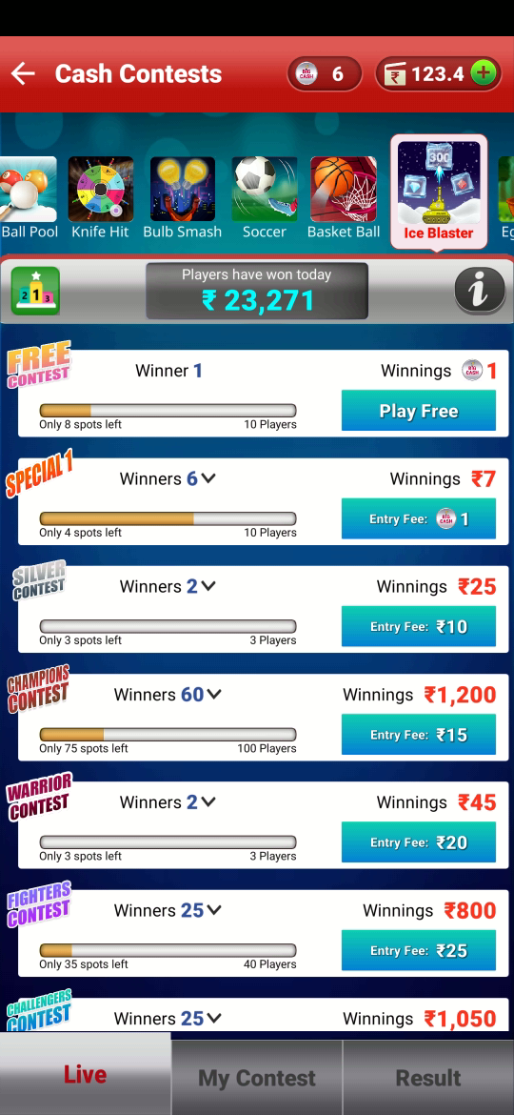

Spots left for players to fill the contest limit.

Leader board

Contest name

Total winners

Max. no. of participant in one contest

Entry fee

Total winning prize

Name of the game

Game information

## Basketball

### How to Enter in Basketball

**If you are not the registered user:**

* Go to [www.bigcash.live](http://www.bigcash.live)
* Click on download option and download the app.
* After installation, open the Big Cash App where user have to do the registration by entering the required credentials.
* Once the registration is done, the big cash app will open and will land you to the home page where all the games icon are displayed.

**In other case, if you are already the registered user:**

* Open the big cash app.
* Now you are on the homepage of Big Cash App where all the games icon are displayed.

**How to select contest and do payment and enter the game:**

* Tap on the basketball game icon in Casual games section.
* Now it will be redirected to contest page.
* From contest page select the contest in which you want play.
* If you don’t have sufficient amount in the wallet, then you will be redirected to the add cash page in the app from where you can add amount in your wallet with the help of different modes for adding cash in the wallet ( like debit/credit card, Google Pay, PhonePe, Net banking, etc. ) and after adding cash u will be redirected to contest page from where you can proceed to next step
* If you have sufficient amount in your wallet, a popup will come to choose payment option, there choose the wallet and tap pay, the amount will be deducted from the wallet, and you will enter the game.

NOTE: the amount will always get deducted from unutilized wallet at first and if the sufficient amount is not present or partially present in the unutilized wallet then the rest amount which is requires will be deducted from winning wallet

### Rules and Regulation

* Hit 60 balls into the basket within 5 minutes.
* Player will get 5 balls to play.
* Results will be declared within 30 minutes after league completion.
* If a smaller number of users participate in the particular contest (same as you) then your money will be refunded within 24 hours.
* Winning of Bigcash token contest and practice will be credited in unutilized balance.

NOTE: On contest section interface there is “i” named button icon from where a play can see rules of the game any time, also leader board icon is present to see world ranking in that game.

### Game Play

* Player has to hit 60 balls into the basket within 5 minutes.
* Player will get 5 balls to play.
* Hitting into the basket gets more difficult as level increases.
* If player gets the ball into the basket while touching the ring of the basket, player will get 20 points.
* If player gets the ball into the basket without touching the ring of the basket, player gets 30 points and 2x multiplier of score for the next hit.
* Player wins if the score is highest among the rest player in that multiplayer game.

### Contests

|  |  |  |  |  |  |  |
| --- | --- | --- | --- | --- | --- | --- |
| Contest | Total Entry (Spot) | Entry Fee | Total Winner | Total winning Prize | Prize Breakup | Platform Fee |
| SPECIAL 1 | 10 | 1 token | 6 | Rs.7 | Rank 1: Rs 2.00  Rank 2: Rs 1.00 | - |
| SILVER | 3 | Rs 10.00 | 2 | Rs.25 | Rank 1: Rs 20.00  Rank 2: Rs 5.00 | Rs 5.00 |
| WARRIOR | 3 | Rs 20.00 | 2 | Rs.45 | Rank 1: Rs 40.00  Rank 2: Rs 5.00 | Rs 15.00 |
| CHAMPIONS | 100 | Rs. 15 | 60 | Rs.1200 | Rank 1: Rs 100.00  Rank 2: Rs 75.00  Rank 3: Rs 55.00  Rank 4: Rs 45.00  Rank 5: Rs 35.00  Rank 6-45: Rs 20.00  Rank 46-60: Rs 6.00 | Rs 300.00 |
| FIGHTERS | 40 | Rs 25.00 | 25 | Rs.800 | Rank 1: Rs 115.00  Rank 2: Rs 100.00  Rank 3: Rs 75.00  Rank 4: Rs 60.00  Rank 5: Rs 50.00  Rank 6-15: Rs 30.00  Rank 16-25: Rs 10.00 | Rs 200.00 |
| CHALLENGERS | 25 | Rs 50.00 | 25 | Rs.1050 | Rank 1: Rs 150.00  Rank 2: Rs 100.00  Rank 3: Rs 95.00  Rank 4: Rs 85.00  Rank 5: Rs 75.00  Rank 6-10: Rs 55.00  Rank 11-15: Rs 54.00  Rank 16-25: 1 Token | Rs 200.00 |

* Practice & spin: In this a player can do practice free, after watching an ad., player will also get a spin wheel to earn different bonus like tokens, cash, or discounts coupons.
* Free Contest: Here player can play free and can win 1 token after scoring to rank 1. there will be one winner. In one multiplayer game 10 players can join.

NOTE: If player lose, player will lose entry fee as well.



Spots left for players to fill the contest limit.

Leader board

Contest name

Total winners

Max. no. of participant in one contest

Entry fee

Total winning prize

Name of the game

Game information

## Fruit Chop

### About

In Fruit Chop game the player has to slice the fruit that appears on the screen using a blade which is controlled using their finger via touch screen sensor. Slicing the fruit will make an increment in their point and extra points will be awarded if the player slices multiple fruit at once. If 3 fruits are missed, the game ends. Occasionally along with fruit bombs appear on the screen and if the player slices the bomb, then also the game will end.

### How to Enter in Fruit chop

**If you are not the registered user:**

* Go to [www.bigcash.live](http://www.bigcash.live)
* Click on download option and download the app.
* After installation, open the Big Cash App where user have to do the registration by entering the required credentials.
* Once the registration is done, the big cash app will open and will land you to the home page where all the games icon are displayed.

**In other case, if you are already the registered user:**

* Open the big cash app.
* Now you are on the homepage of Big Cash App where all the games icon are displayed.

**How to select contest and do payment and enter the game:**

* Tap on the fruit chop game icon in Casual games section.
* Now it will be redirected to contest page.
* From contest page select the contest in which you want play.
* If you don’t have sufficient amount in the wallet, then you will be redirected to the add cash page in the app from where you can add amount in your wallet with the help of different modes for adding cash in the wallet ( like debit/credit card, Google Pay, PhonePe, Net banking, etc. ) and after adding cash u will be redirected to contest page from where you can proceed to next step
* If you have sufficient amount in your wallet, a popup will come of choose payment option, there chose the wallet and tap pay, the amount will be deducted from the wallet, and you will enter the game.

NOTE: the amount will always get deducted from unutilized wallet at first and if the sufficient amount is not present or partially present in the unutilized wallet then the rest amount which is requires will be deducted from winning wallet

### Game Play

* Start the game, fruits will start coming out from the bottom of the screen and falling back again. Players need to finish their game within 3 minutes and results will be declared within 30 minutes.
* Swipe your fingers on the fruit to slice them and earn points.
* Slicing multiple fruits at a time will add bonus points to the score.

### Game ends

* if the player fails to slice 3 fruits consecutively.
* If the player slices a bomb that comes along the fruit occasionally.

### Contest, entry fee and winnings.

|  |  |  |  |  |  |  |
| --- | --- | --- | --- | --- | --- | --- |
| CONTEST | Total Entry (Spot) | Entry Fee | Total Winner | Total winning Prize | Prize Breakup | Platform Fee |
| SPECIAL 1 | 10 | 1 token | 6 | Rs.7 | Rank 1: Rs 2.00  Rank 2: Rs 1.00 | - |
| SILVER | 3 | Rs 10.00 | 2 | Rs.25 | Rank 1: Rs 20.00  Rank 2: Rs 5.00 | Rs 5.00 |
| WARRIOR | 3 | Rs 20.00 | 2 | Rs.45 | Rank 1: Rs 40.00  Rank 2: Rs 5.00 | Rs 15.00 |
| CHAMPIONS | 100 | Rs. 15 | 60 | Rs.1200 | Rank 1: Rs 100.00  Rank 2: Rs 75.00  Rank 3: Rs 55.00  Rank 4: Rs 45.00  Rank 5: Rs 35.00  Rank 6-45: Rs 20.00  Rank 46-60: Rs 6.00 | Rs 300.00 |
| FIGHTERS | 40 | Rs 25.00 | 25 | Rs.800 | Rank 1: Rs 115.00  Rank 2: Rs 100.00  Rank 3: Rs 75.00  Rank 4: Rs 60.00  Rank 5: Rs 50.00  Rank 6-15: Rs 30.00  Rank 16-25: Rs 10.00 | Rs 200.00 |
| CHALLENGERS | 25 | Rs 50.00 | 25 | Rs.1050 | Rank 1: Rs 150.00  Rank 2: Rs 100.00  Rank 3: Rs 95.00  Rank 4: Rs 85.00  Rank 5: Rs 75.00  Rank 6-10: Rs 55.00  Rank 11-15: Rs 54.00  Rank 16-25: 1 Token | Rs 200.00 |
| SUPER | 2 | Rs 60.00 | 1 | Rs.100 | Rank 1: Rs 100.00 | Rs 20.00 |
| GOLD | 2 | Rs.110 | 2 | Rs.220 | Rank 1: Rs.200  Rank 2: 1 Token | Rs.20.00 |

* A practice and a free contest are also available.
* In free contest there are total 10 spots with 1 winner and the winning prize are 1 Token.
* If less number of users participated in your contest, then your money will be refunded within 24 hours.
* Winning of Token contest and practice contest will be credited to unutilized balance.

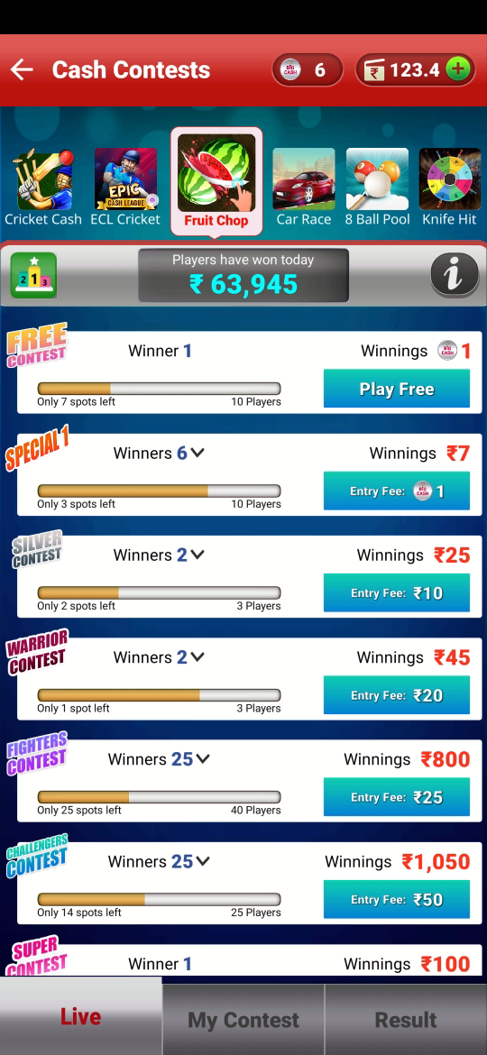

Spots left for players to fill the contest limit.

Leader board

Contest name

Total winners

Max. no. of participant in one contest

Entry fee

Total winning prize

Name of the game

Game information

## Soccer

### About

The motto of the game is to score as many goals as possible by swiping the ball towards the goal using the finger. To gain bonus points, you need to hit the colored zones that gets highlighted when you hit the goal. Depending on the which area of goal you hit, your points will be added to your score board.

### How to Enter in Soccer

**If you are not the registered user:**

* Go to [www.bigcash.live](http://www.bigcash.live)
* Click on download option and download the app.
* After installation, open the Big Cash App where user have to do the registration by entering the required credentials.
* Once the registration is done, the big cash app will open and will land you to the home page where all the games icon are displayed.

**In other case, if you are already the registered user:**

* Open the big cash app.
* Now you are on the homepage of Big Cash App where all the games icon are displayed.

**How to select contest and do payment and enter the game:**

* Tap on the soccer game icon in Casual games section.
* Now it will be redirected to contest page.
* From contest page select the contest in which you want play.
* If you don’t have sufficient amount in the wallet, then you will be redirected to the add cash page in the app from where you can add amount in your wallet with the help of different modes for adding cash in the wallet ( like debit/credit card, Google Pay, PhonePe, Net banking, etc. ) and after adding cash u will be redirected to contest page from where you can proceed to next step
* If you have sufficient amount in your wallet, a popup will come of choose payment option, there chose the wallet and tap pay, the amount will be deducted from the wallet, and you will enter the game.

NOTE: the amount will always get deducted from unutilized wallet at first and if the sufficient amount is not present or partially present in the unutilized wallet then the rest amount which is requires will be deducted from winning wallet

### Game Play

* Entering the game, a goal post, goalkeeper, and a football will appear on the screen.
* The football needs to be swiped using the finger towards the goalpost**.**
* Frequently some colored circle will appear on the goalpost hit ball on them and get bonus points (Purple circle – 2 points, Orange circle – 3 points, Red circle – 4 points).

### Game Ends

* If the player misses to goal ball 3 times and completes maximum 60 hits
* If 3 minutes are over after entering the game.

### Contest, entry fee and winnings

|  |  |  |  |  |  |  |
| --- | --- | --- | --- | --- | --- | --- |
| CONTEST | Total Entry (Spot) | Entry Fee | Total Winner | Total winning Prize | Prize Breakup | Platform Fee |
| SPECIAL 1 | 10 | 1 token | 6 | Rs.7 | Rank 1: Rs 2.00  Rank 2: Rs 1.00 | - |
| SILVER | 3 | Rs 10.00 | 2 | Rs.25 | Rank 1: Rs 20.00  Rank 2: Rs 5.00 | Rs 5.00 |
| WARRIOR | 3 | Rs 20.00 | 2 | Rs.45 | Rank 1: Rs 40.00  Rank 2: Rs 5.00 | Rs 15.00 |
| CHAMPIONS | 100 | Rs. 15 | 60 | Rs.1200 | Rank 1: Rs 100.00  Rank 2: Rs 75.00  Rank 3: Rs 55.00  Rank 4: Rs 45.00  Rank 5: Rs 35.00  Rank 6-45: Rs 20.00  Rank 46-60: Rs 6.00 | Rs 300.00 |
| FIGHTERS | 40 | Rs 25.00 | 25 | Rs.800 | Rank 1: Rs 115.00  Rank 2: Rs 100.00  Rank 3: Rs 75.00  Rank 4: Rs 60.00  Rank 5: Rs 50.00  Rank 6-15: Rs 30.00  Rank 16-25: Rs 10.00 | Rs 200.00 |
| CHALLENGERS | 25 | Rs 50.00 | 25 | Rs.1050 | Rank 1: Rs 150.00  Rank 2: Rs 100.00  Rank 3: Rs 95.00  Rank 4: Rs 85.00  Rank 5: Rs 75.00  Rank 6-10: Rs 55.00  Rank 11-15: Rs 54.00  Rank 16-25: 1 Token | Rs 200.00 |

* A practice and a free contest are also available.
* In free contest there are total 10 spots with 1 winner and the winning prize are 1 Token.
* If less number of users participated in your contest, then your money will be refunded within 24 hours.
* Winning of Token contest and practice contest will be credited to unutilized balance.

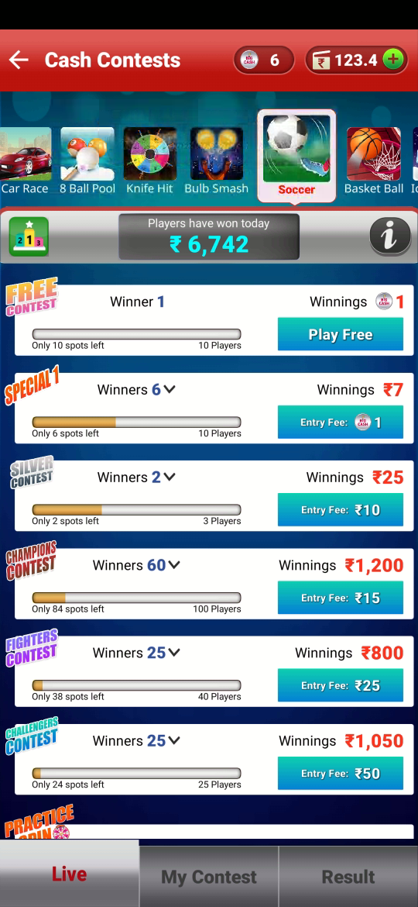

Spots left for players to fill the contest limit.

Leader board

Contest name

Total winners

Max. no. of participant in one contest

Entry fee

Total winning prize

Name of the game

Game information

## Cricket

### How to Enter in Cricket

**If you are not the registered user:**

* Go to [www.bigcash.live](http://www.bigcash.live)
* Click on download option and download the app.
* After installation, open the Big Cash App where user have to do the registration by entering the required credentials.
* Once the registration is done, the big cash app will open and will land you to the home page where all the games icon are displayed.

**In other case, if you are already the registered user:**

* Open the big cash app.
* Now you are on the homepage of Big Cash App where all the games icon are displayed.

**How to select contest and do payment and enter the game:**

* Tap on the cricket game icon in Casual games section.
* Now it will be redirected to contest page.
* From contest page select the contest in which you want play.
* If you don’t have sufficient amount in the wallet, then you will be redirected to the add cash page in the app from where you can add amount in your wallet with the help of different modes for adding cash in the wallet (like debit/credit card, Google Pay, PhonePe, Net banking, etc.) and after adding cash u will be redirected to contest page from where you can proceed to next step.
* If you have sufficient amount in your wallet, a popup will come of choose payment option, there chose the wallet and tap pay, the amount will be deducted from the wallet, and you will enter the game.

NOTE: the amount will always get deducted from unutilized wallet at first and if the sufficient amount is not present or partially present in the unutilized wallet then the rest amount which is requires will be deducted from winning wallet

### Rules and Regulation

* Hit 60 balls within 10 minutes.
* Player will get 3 wickets to play.
* Results will be declared within 30 minutes after league completion.
* If a smaller number of users participate in the particular contest (same as you) then your money will be refunded within 24 hours.
* Winning of bigcash token contest and practice will be credited in unutilized balance.

NOTE: On contest section interface there is “i” named button icon from where a play can see rules of the game any time, also leader board icon is present to see world ranking in that game.

### Game Play

* Player has to hit 60 balls within 10 minutes.
* Player will get 3 wickets to play.
* Player wins if the score is highest among the rest player in that multiplayer game.

### Contests

|  |  |  |  |  |  |  |
| --- | --- | --- | --- | --- | --- | --- |
| Contest | Total Entry (Spot) | Entry Fee | Total Winner | Total winning Prize | Prize Breakup | Platform Fee |
| SPECIAL 1 | 10 | 1 token | 6 | Rs.7 | Rank 1: Rs 2.00  Rank 2: Rs 1.00 | - |
| SILVER | 3 | Rs 10.00 | 2 | Rs.25 | Rank 1: Rs 20.00  Rank 2: Rs 5.00 | Rs 5.00 |
| WARRIOR | 3 | Rs 20.00 | 2 | Rs.45 | Rank 1: Rs 40.00  Rank 2: Rs 5.00 | Rs 15.00 |
| CHAMPIONS | 100 | Rs. 15 | 60 | Rs.1200 | Rank 1: Rs 100.00  Rank 2: Rs 75.00  Rank 3: Rs 55.00  Rank 4: Rs 45.00  Rank 5: Rs 35.00  Rank 6-45: Rs 20.00  Rank 46-60: Rs 6.00 | Rs 300.00 |
| FIGHTERS | 40 | Rs 25.00 | 25 | Rs.800 | Rank 1: Rs 115.00  Rank 2: Rs 100.00  Rank 3: Rs 75.00  Rank 4: Rs 60.00  Rank 5: Rs 50.00  Rank 6-15: Rs 30.00  Rank 16-25: Rs 10.00 | Rs 200.00 |
| CHALLENGERS | 25 | Rs 50.00 | 25 | Rs.1050 | Rank 1: Rs 150.00  Rank 2: Rs 100.00  Rank 3: Rs 95.00  Rank 4: Rs 85.00  Rank 5: Rs 75.00  Rank 6-10: Rs 55.00  Rank 11-15: Rs 54.00  Rank 16-25: 1 Token | Rs 200.00 |
| GOLD | 2 | Rs.110 | 2 | Rs.220 | Rank 1: Rs.200  Rank 2: 1 Token | Rs.20.00 |
| PLATINUM | 2 | Rs.550 | 2 | Rs. 1000 | Rank 1: Rs.1000  Rank 2: 5 Tokens | Rs. 100 |

* Practice & spin: In this a player can do practice free, after watching an ad., player will also get a spin wheel to earn different bonus like tokens, cash, or discounts coupons.
* Free Contest: Here player can play free and can win 1 token after scoring to rank 1. there will be one winner. In one multiplayer game 10 players can join.

NOTE: If player lose, player will lose entry fee as well.

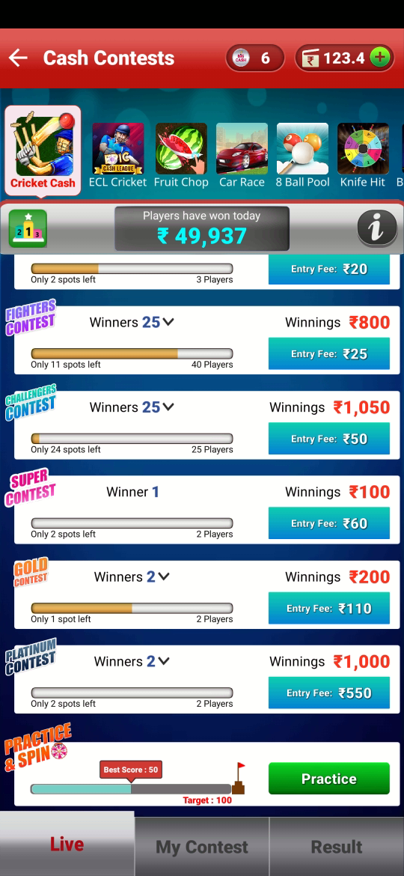

Spots left for players to fill the contest limit.

Leader board

Contest name

Total winners

Max. no. of participant in one contest

Entry fee

Total winning prize

Name of the game

Game information

## Car Race

### About

Car race is fun racing game. Here player drive car in a city highway where other vehicles are also moving. Using the touch gesture players can change the direction of the car from left to right and vice versa. In between journey the players will get the opportunity to collect Gems and Diamonds and if the car hits to another vehicle the game ends.

### How to Enter in car race

**If you are not the registered user:**

* Go to [www.bigcash.live](http://www.bigcash.live)
* Click on download option and download the app.
* After installation, open the Big Cash App where user have to do the registration by entering the required credentials.
* Once the registration is done, the big cash app will open and will land you to the home page where all the games icon are displayed.

**In other case, if you are already the registered user:**

* Open the big cash app.
* Now you are on the homepage of Big Cash App where all the games icon are displayed.

**How to select contest and do payment and enter the game:**

* Tap on the car race game icon in Casual games section.
* Now it will be redirected to contest page.
* From contest page select the contest in which you want play.
* If you don’t have sufficient amount in the wallet, then you will be redirected to the add cash page in the app from where you can add amount in your wallet with the help of different modes for adding cash in the wallet ( like debit/credit card, Google Pay, PhonePe, Net banking, etc. ) and after adding cash u will be redirected to contest page from where you can proceed to next step
* If you have sufficient amount in your wallet, a popup will come of choose payment option, there chose the wallet and tap pay, the amount will be deducted from the wallet, and you will enter the game.

NOTE: the amount will always get deducted from unutilized wallet at first and if the sufficient amount is not present or partially present in the unutilized wallet then the rest amount which is requires will be deducted from winning wallet

### Game Play

* Complete as much distance you can in 5 minutes.
* Collect Diamonds and Gems while travelling to increase your score (*1 Diamond = 30 points and 1 Gem = 20 points).*
* Swipe fingers left or right to change the road lane.

### Game Ends

* If 5 minutes are complete.
* If the player hits another car.

### Contest, entry fee and winnings

|  |  |  |  |  |  |  |
| --- | --- | --- | --- | --- | --- | --- |
| CONTEST | Total Entry (Spot) | Entry Fee | Winner | Total winning Prize | Prize Breakup | Platform Fee |
| SPECIAL 1 | 10 | 1 token | 6 | Rs.7 | Rank 1: Rs 2.00  Rank 2: Rs 1.00 | - |
| SILVER | 3 | Rs 10.00 | 2 | Rs.25 | Rank 1: Rs 20.00  Rank 2: Rs 5.00 | Rs 5.00 |
| CHAMPIONS | 100 | Rs 15.00 | 60 | Rs.45 | Rank 1: Rs 100.00  Rank 2: Rs 75.00  Rank 3: Rs 55.00  Rank 4: Rs 45.00  Rank 5: Rs 35.00  Rank 6-45: Rs 20.00  Rank 46-100: Rs 6.00 | Rs 300.00 |
| WARRIOR | 3 | Rs 20.00 | 2 | Rs.1200 | Rank 1: Rs 40.00  Rank 2: Rs 5.00 | Rs 15.00 |
| FIGHTERS | 40 | Rs 25.00 | 25 | Rs.800 | Rank 1: Rs 115.00  Rank 2: Rs 100.00  Rank 3: Rs 75.00  Rank 4: Rs 60.00  Rank 5: Rs 50.00  Rank 6-15: Rs 30.00  Rank 16-25: Rs 10.00 | Rs 200.00 |
| CHALLENGERS | 25 | Rs 50.00 | 25 | Rs.1050 | Rank 1: Rs 150.00  Rank 2: Rs 100.00  Rank 3: Rs 95.00  Rank 4: Rs 85.00  Rank 5: Rs 75.00  Rank 6-10: Rs 55.00  Rank 11-15: Rs 54.00  Rank 16-25: 1 Big  Cash token | Rs 200.00 |
| SUPER | 2 | Rs 60.00 | 1 | Rs.100 | Rank1: Rs 100.00 | Rs. 20.00 |
| GOLD | 2 | Rs 110.00 | 2 | Rs.200 | Rank 1: Rs 200.00  Rank 2: 2 Token | Rs. 20.00 |
| PLATINUM | 2 | Rs 550.00 | 2 | Rs.1000 | Rank 1: Rs 1000.00  Rank 2: 5 Token | Rs. 100.00 |

* A practice and a free contest are also available.
* In free contest there are total 10 spots with 1 winner and the winning prize are 1 Token.
* If less number of users participated in your contest, then your money will be refunded within 24 hours.
* Winning of Token contest and practice contest will be credited to unutilized balance.

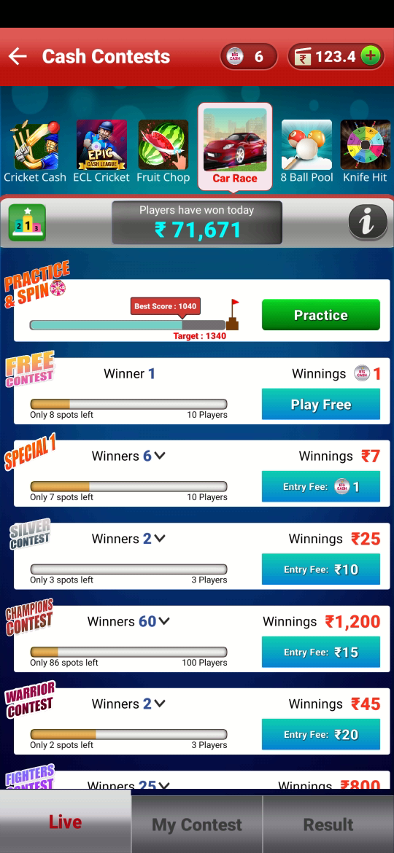

Spots left for players to fill the contest limit.

Leader board

Contest name

Total winners

Max. no. of participant in one contest

Entry fee

Total winning prize

Name of the game

Game information

## Big Ludo

### About

Big Ludo is a casual game played between 2-4 players. Every player gets 4 pawns and it’s the players call to use which pawn when, all the moves are predefined and a pawn has to travel 56 `blocks in board to reach the home

### Game Play

* Each player will get 24 moves with predefined values
* Score equals to number of blocks travelled by the pawn
* Player will be dropped from the game on missing 3 turns
* On eliminating opponent pawn player will get an extra move and +2 in their score
* If opponent captures the pawn, then player will lose the score which is equal to the total number of blocks travelled by the pawn.
* Extra move +56 score will be added if a pawn reaches to the home
* If players pawn share same block(space) +2 score will be added.

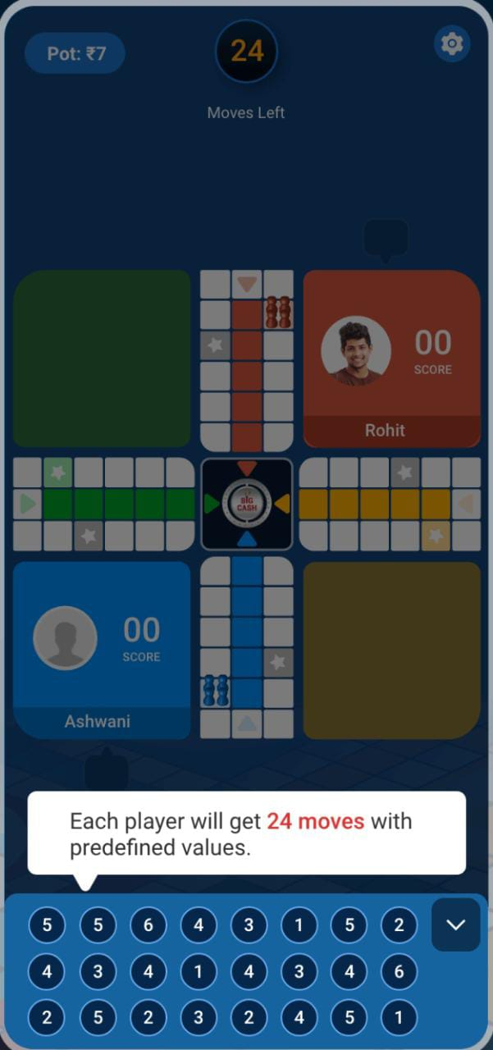 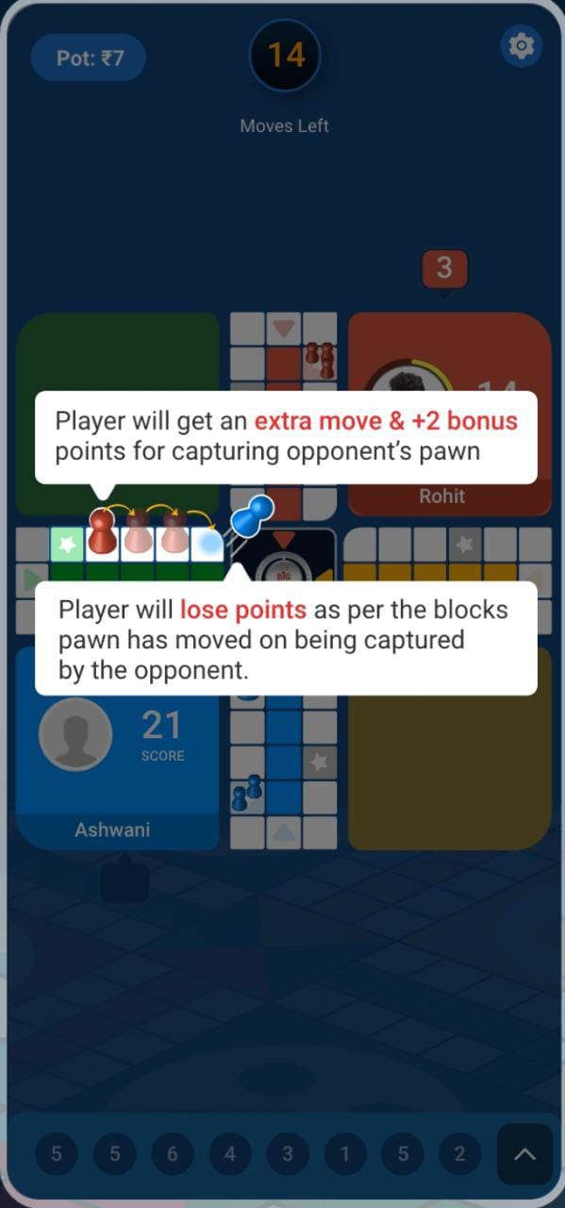 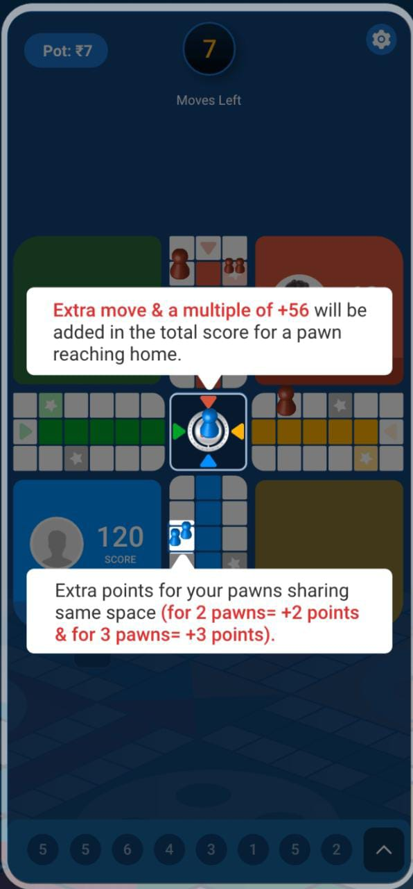

### Contest, entry fee and winnings

|  |  |  |  |  |
| --- | --- | --- | --- | --- |
| Entry  Fee (Rs.) | No. of  Players | Winning Amount (Rs.) | No. of  Winners | Platform  Fee |
| 3 to 100 | 2 | 5 to 180 | 1 | 10% to 16.7% |

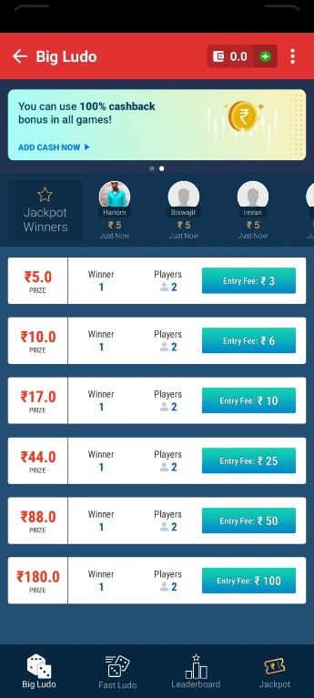

No. of Winners

No. of Players

Winning

Entry Fee

## Fast Ludo

### About

fast Ludo another format of ludo where game is played between 2-4 players. Every player gets 4 pawns and it’s the players call to use which pawn when, all the moves are predefined and a pawn has to travel 56 `blocks in board to reach the home

### Game Play

* Each player will get 12 moves with predefined values
* Score equals to number of blocks travelled by the pawn
* Player will be dropped from the game on missing 3 turns
* On eliminating opponent pawn player will get an extra move and +2 in their score
* If opponent captures the pawn, then player will lose the score which is equal to the total number of blocks travelled by the pawn.
* Extra move +29 score will be added if a pawn reaches to the home
* If players 2 pawn share same block(space) +2 score will be added & if 3 pawn share same block(space) then +3 score will be added.

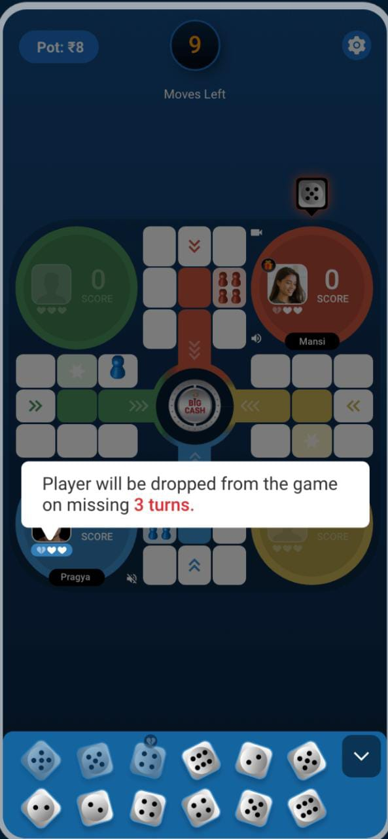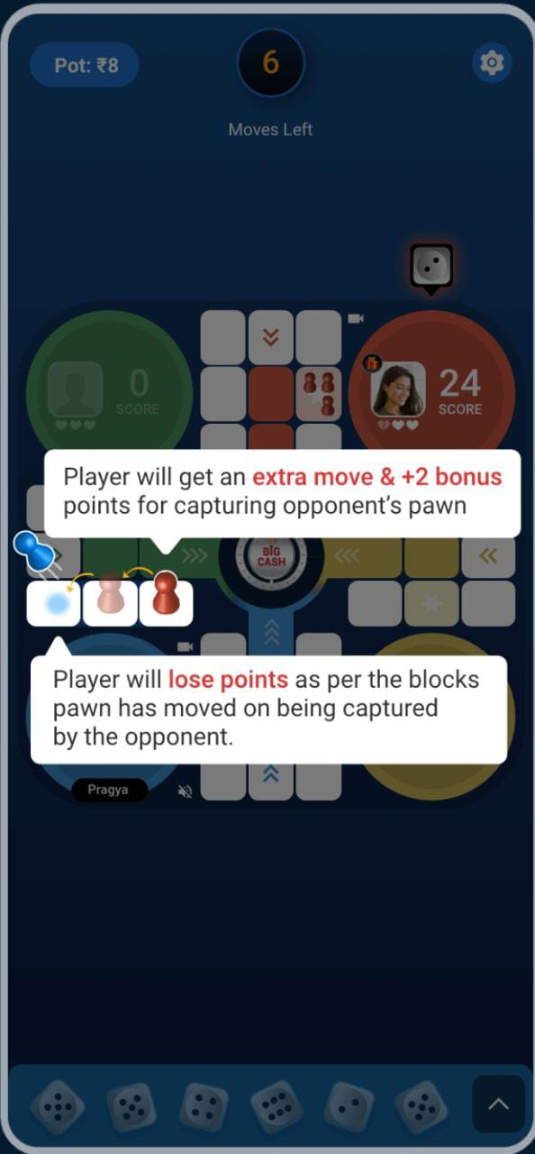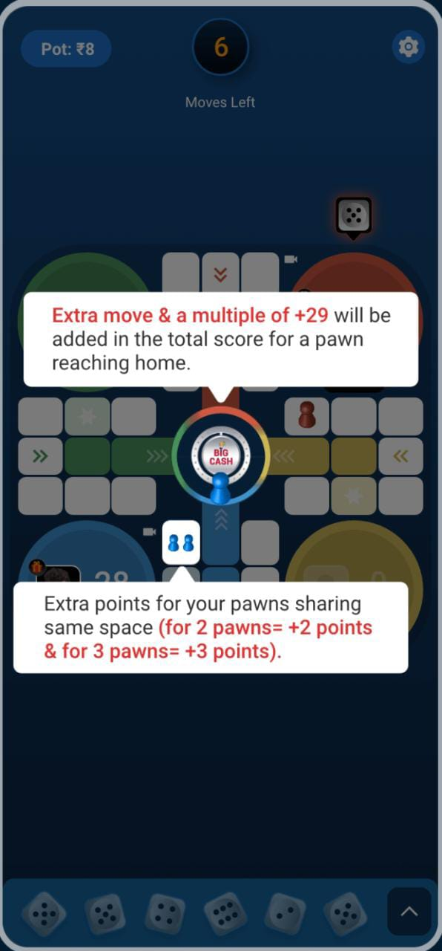

### Contest, entry fee and winnings

|  |  |  |  |  |
| --- | --- | --- | --- | --- |
| Entry  Fee (Rs.) | No. of  Players | Winning Amount (Rs.) | No. of  Winners | Platform  Fee |
| 3 to 250 | 2 | 5 to 450 | 1 | 10% to 16.7% |

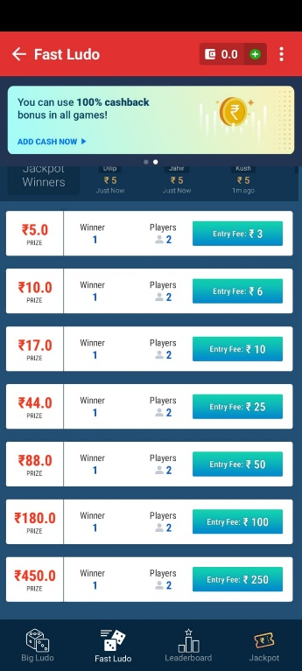

No. of Winners

No. of Players

Winning

Entry Fee

# CHAPTER 4: FANTASY GAMES

**Fantasy games** are a virtual form of your favorite sports. They help users get closer to the sport they so love and adore. Players in BigCash platform can use their sports knowledge and skill, you can create your own team by picking real players for **Fantasy** Cricket, **Fantasy** Football, and **Fantasy** Kabaddi.

FANTASY GAMES



 FANTASY CRICKET

 FANTASY FOOTBALL

FANTASY KABADDI

## Fantasy Cricket

### About

In fantasy cricket user can create their own cricket team(virtual) of 11 players for upcoming real matches (Domestic/International including all T10, T20, ODI, Test, etc.)

### How to Enter in Fantasy football

**If you are not the registered user:**

* Go to [www.bigcash.live](http://www.bigcash.live)
* Click on download option and download the app.
* After installation, open the Big Cash App where user have to do the registration by entering the required credentials.
* Once the registration is done, the big cash app will open and will land you to the home page where all the games icon are displayed.

**In other case, if you are already the registered user:**

* Open the big cash app.
* Now you are on the homepage of Big Cash App where all the games icon are displayed.

**How to select contest and do payment and enter the game:**

* Tap on the Cricket fantasy game icon.
* Now it will be redirected to contest page.
* From contest page select the contest in which you want play.
* If you don’t have sufficient amount in the wallet, then you will be redirected to the add cash page in the app from where you can add amount in your wallet with the help of different modes for adding cash in the wallet ( like debit/credit card, Google Pay, PhonePe, Net banking, etc. ) and after adding cash u will be redirected to contest page from where you can proceed to next step
* If you have sufficient amount in your wallet, a popup will come of choose payment option, there chose the wallet and tap pay, the amount will be deducted from the wallet, and you will enter the game.

NOTE: The amount will always get deducted from unutilized wallet at first and if the sufficient amount is not present or partially present in the unutilized wallet then the rest amount which is requires will be deducted from winning wallet.

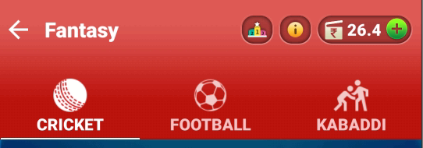NOTE: User can switch football fantasy and Kabaddi fantasy as well by the tab provided above.

### Objective

The main objective of the user is to achieve the points as much as possible and get the position on the leadership board.

### Game Play

* Create a virtual team of 11 players from the two teams.
* While creating the teams you will have the option to pick 3-6 Batsmen, 3-6 Bowlers, 1-4 All Rounder, 1-4 Wicketkeeper (Make combination as per your requirements).
* Each user will be given in total 100 credits to spend on the players.
* Based on the past performance of the players each player has its own credit price.
* Users have to spend their credit points to purchase each player which can’t exceed 100 credit points.
* After creating the team, the user will have the option to choose the captain for the team he built. The captain gets 2x the Points.

### Note

* You can participate or update your team before match starts.
* Results will be declared within 12 hours of match end.
* If a smaller number of users participate in your contest, then your money will be refunded.
* In case of same score, prize will be distributed equally.
* You can view other players team after match starts.
* Maximum 7 players can be selected from one team.

### Contest Table

|  |  |  |  |  |  |  |
| --- | --- | --- | --- | --- | --- | --- |
| Contest | Total Entry (Spot) | Entry Fee | Winner | Total Winning Prize | Prize Breakup | Platform Fee |
| Type 1 | 40 | Rs 25.00 | 25 | Rs.800 | Rank 1: Rs 115.00  Rank 2: Rs 100.00  Rank 3: Rs 75.00  Rank 4: Rs 60.00  Rank 5: Rs 50.00  Rank 6-15: Rs 30.00  Rank 16-25: Rs 10.00 | Rs 200.00 |
| Type 2 | 3 | Rs 50.00 | 2 | Rs.125 | Rank 1: Rs 100.00  Rank 2: Rs 25.00 | Rs 25.00 |
| Type 3 | 3 | Rs 10.00 | 2 | Rs.25 | Rank 1: Rs 20.00  Rank 2: Rs 5.00 | Rs 30.00 |
| Type 4 | 2 | Rs 110.00 | 1 | Rs.200 | Rank 1: Rs 200.00 | Rs 20.00 |
| Type 5 | 2 | Rs 550.00 | 1 | Rs.1000 | Rank 1: Rs 1000.00 | Rs 100.00 |
| Type 6 | 2 | Rs 1100.00 | 1 | Rs.2000 | Rank 1: Rs 2000.00 | Rs 200.00 |
| Type 7 | 6 | Rs 35.00 | 2 | Rs.160 | Rank 1: Rs 100.00  Rank 2: Rs 60.00 | Rs 50.00 |
| Type 8 | 100 | Rs 15.00 | 60 | Rs.1200 | Rank 1: Rs 100.00  Rank 2: Rs 75.00  Rank 3: Rs 55.00  Rank 4: Rs 45.00  Rank 5: Rs 35.00  Rank 6-45: Rs 20.00  Rank 46-100: Rs 6.00 | Rs 300.00 |
| Type 9 | 3 | Rs 20.00 | 2 | Rs.45 | Rank 1: Rs 40.00  Rank 2: Rs 5.00 | Rs 15.00 |
| Type 10 | 2 | Rs 60.00 | 1 | Rs.100 | Rank 1: Rs 100.00 | Rs 20.00 |
| Type 11 | 2 | Rs 2750.00 | 1 | Rs.5000 | Rank 1: Rs 5000.00 | RS 500.00 |



Deadline/ time left to start the match.

Spots left for the players to fill the contest.

Total winners to be awarded.

Match between

contest limit

Entry fee

Total winning prize

Wallet balance

## Fantasy Football

### About

Build your dream team(virtual) with your favorite football players who are playing in same team as well as opponents. Users can create their team.

### How to Enter in Fantasy football

**If you are not the registered user:**

* Go to [www.bigcash.live](http://www.bigcash.live)
* Click on download option and download the app.
* After installation, open the Big Cash App where user have to do the registration by entering the required credentials.
* Once the registration is done, the big cash app will open and will land you to the home page where all the games icon are displayed.

**In other case, if you are already the registered user:**

* Open the big cash app.
* Now you are on the homepage of Big Cash App where all the games icon are displayed.

**How to select contest and do payment and enter the game:**

* Tap on the Football fantasy game icon.
* Now it will be redirected to contest page.
* From contest page select the contest in which you want play.
* If you don’t have sufficient amount in the wallet, then you will be redirected to the add cash page in the app from where you can add amount in your wallet with the help of different modes for adding cash in the wallet ( like debit/credit card, Google Pay, PhonePe, Net banking, etc. ) and after adding cash u will be redirected to contest page from where you can proceed to next step
* If you have sufficient amount in your wallet, a popup will come of choose payment option, there chose the wallet and tap pay, the amount will be deducted from the wallet, and you will enter the game.

NOTE: The amount will always get deducted from unutilized wallet at first and if the sufficient amount is not present or partially present in the unutilized wallet then the rest amount which is requires will be deducted from winning wallet.

NOTE: User can switch cricket fantasy and Kabaddi fantasy as well by the tab provided above.

### Rules and Regulation

* Player can participate or update their team before match start.
* Results will be declared within 12 hours of match end.
* If a smaller number of users participate in that contest, then the player’s money will be refunded.
* In case of same score users who have participated earlier will win.
* Player can view other players team after match starts.

Playing time rules

* Played 55 minutes or more: +2
* Played less than 55 minutes: +1

Attack Rules

* For every goal scored (GK/ Defender): +10
* For every goal scored (Midfielder): +9
* For every goal scored (Forward): +8
* For every assist: +5
* For every 10 passes completed: +1
* For every 2 shots on target: +1

Defense Rules

* Clean sheet (midfielder): +1
* Clean Sheet (GK/ Defender): +5
* For every 3 shots saved (GK): +2
* For every plenty saved (GK): +9
* For every 3 successful tackles made: +1

Cards and Other rules

* Yellow card: -1
* Red card: -3
* For every own goal: -2
* For Every 2-goal conceded: -1
* For every penalty missed: -2

NOTE: On contest section interface there is “i” named button icon from where a play can see rules of the game any time, also leader board icon is present to see world ranking in that game.

### Game Play

* Choose 11 players and create team.
* Maximum 7 players can be selected from the same team.
* Select the match to which you want to play.
* While creating the team you will have option to pick 1 Goalkeeper, 1-3 Forwards, 3-5 Defenders, 3-5 Midfielders.
* Each user will be given in total 100 credits to spend on the players.
* Based on the past performance of the players each player has its own credit price.
* Users have to spend their credit points to purchase each player which can’t exceed 100 credit points.
* After creating the team, the user will have the option to choose the captain for the team he built. The captain gets 2x the Points.

### Note

* You can participate or update your team before match starts.
* Results will be declared within 12 hours of match end.
* If a smaller number of users participate in your contest, then your money will be refunded.
* In case of same score, prize will be distributed equally.
* You can view other players team after match starts.
* Maximum 7 players can be selected from one team.

### Contest, entry fee and winnings

|  |  |  |  |  |  |  |
| --- | --- | --- | --- | --- | --- | --- |
| Contest | Total Entry (Spot) | Entry Fee | Winner | Total Winning Prize | Prize Breakup | Platform Fee |
| Challengers | 3 | Rs 50.00 | 2 | Rs.125 | Rank 1: Rs 100.00  Rank 2: Rs 25.00 | Rs 25.00 |
| Silver | 3 | Rs 10.00 | 2 | Rs.25 | Rank 1: Rs 20.00  Rank 2: Rs 5.00 | Rs 5.00 |
| Gold | 2 | Rs 110.00 | 1 | Rs.200 | Rank 1: Rs 200.00 | Rs 20.00 |
| Titanium | 6 | Rs 35.00 | 2 | Rs.160 | Rank 1: Rs 100.00  Rank 2: Rs 60.00 | Rs 50.00 |

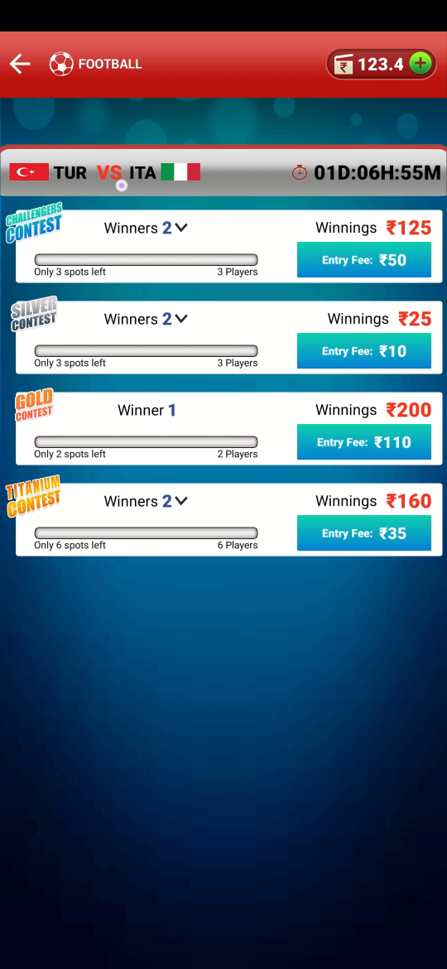

Deadline/ time left to start the match.

spots left for players to fill the contest.

Match between

contest name

Total winners

contest limit

total winning prize

Entry fee

Wallet balance

# CHAPTER 5: POKER T.v

## About

Big Cash provide their users a unique feature of watching live Poker matches which are ongoing on Big Cash platform. Users can here learn how to play and enhance their skills by watching live Poker matches in the Poker TV.

Open Bigcash app

Open Poker game and tap on the Poker T.V banner at the top of the home screen

You will be redirected to live ongoing Poker match.

## How to watch Poker TV

**Step 1:** Open Big Cash app and tap on the POKER under trending section.



**Step 2:** You will then be directed to contest page of online poker. Check at the top, you will find a banner of POKER TV.

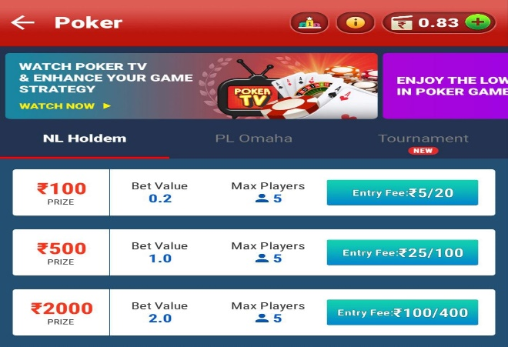

**Step 3:** Tap on the POKER TV banner, you will be redirected to the live poker match.

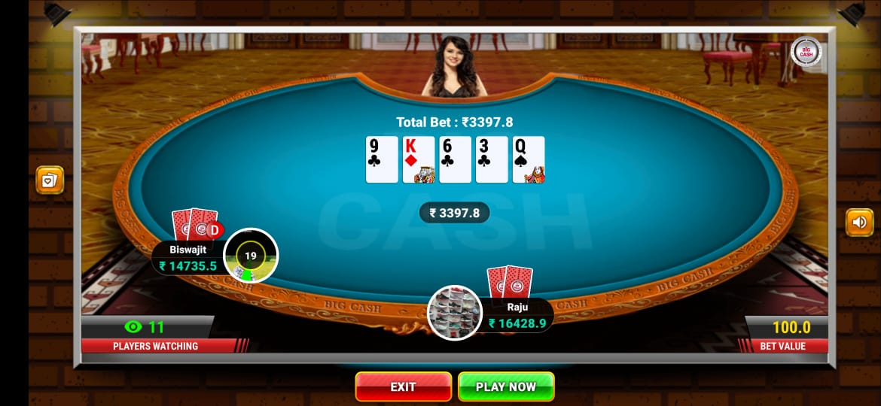

Total Players watching the LIVE game.

Here users can watch live poker, improve their skills and strategies and when feels to play can directly tap on PLAY NOW button and will be directed to the Poker contest page.

# CHAPTER 6: INVITE AND EARN

## About

Big Cash app provides you an opportunity to earn real money just by inviting your friends and known ones by sending an invitation link.

Users of Big Cash app can also increase their earnings just by inviting new users to the Big Cash app platform and with this they get benefits of **BIG CASH Invite and Earn program** as well as **Invite and Earn monthly contest.**

Go to menu and tap on Invite & Earn or check the banner on top of the home page.

Invite and Earn Monthly Contest

A banner will appear describing your rank, points, and winnings.

Invite new users and earn.

You will get option to share the Big Cash app link with your referral code attached through Facebook, WhatsApp, Direct Message, etc.

OR

when the user completes the game play of any casual game in Big Cash app, he/she will get the option to invite their friends through WhatsApp.

Click on the banner to see the rank, points, and winnings of other users in referral contest.

You will get option to share the Big Cash app link with your referral code attached through Facebook, WhatsApp, Direct Message, etc.

## BIG CASH Invite and Earn program

Here the user just needs to follow the simple process of inviting their friends and known ones by sending an invitation link via BigCash app platform. Do follow the following steps.

**Step1:** Download the BIG CASH app and register yourself.

**Step 2:** Click on the Big Cash menu TOP LEFT of your screen.

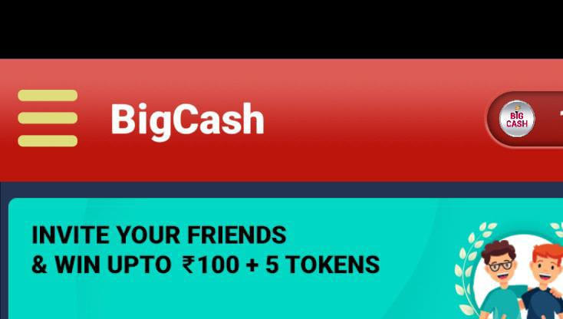

**Step 3:** Select Invite Earn.

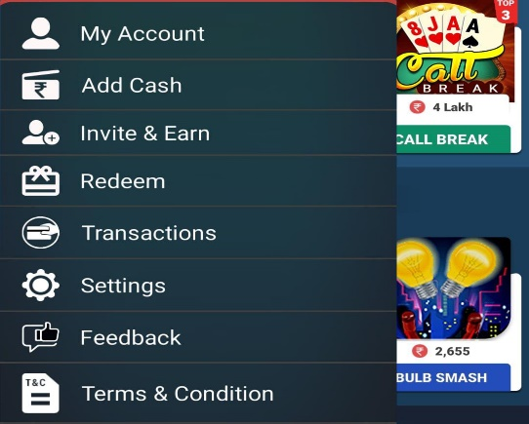

**Step 4:** You will get option to share the Big Cash app link with your referral code attached through Facebook, WhatsApp, Direct Message, etc.

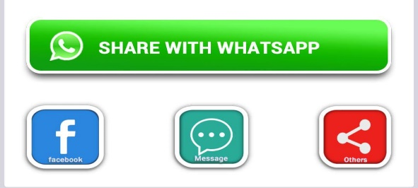

Or click on the banner “INVITE NOW” in the Home section of the app.

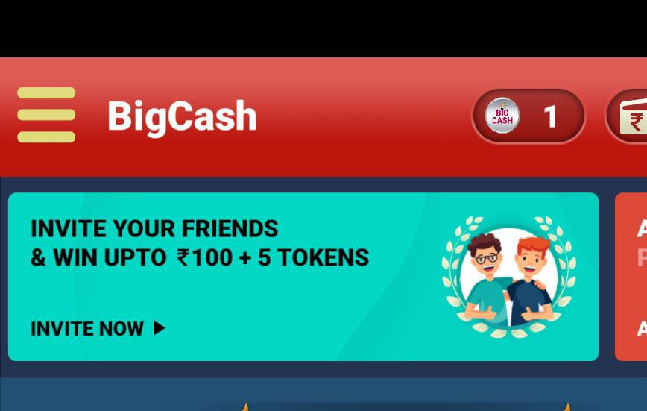

Or, when the user completes the game play of any casual game in Big Cash app, he/she will get the option to invite their friends through WhatsApp.

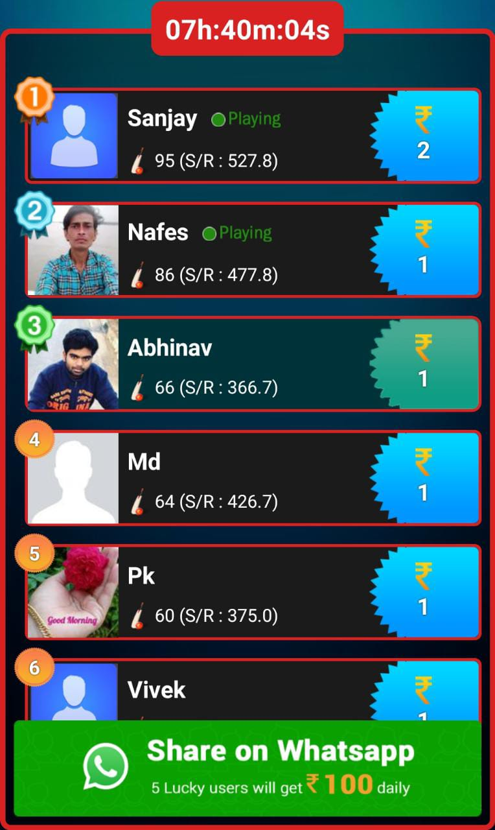

### Benefits

* Rs. 30 will credited to the Referrer’s winning wallet when Referee does his first deposit (add cash).
* Rs. 5.00 will be credited to Referrer’s winning wallet every time referee adds cash Rs. 100 or more.
* If Referee register through their real Facebook and Google account they get Rs20 joining bonus.

### Invite and Earn Monthly Contest

* Big Cash gives their user’s opportunity to win up to Rs. 500000 every month.
* Referrer will get 1 point for every Referee who links his Big Cash app with Facebook account.
* User will get 5 points, if Referee links their Paytm account with Big Cash app.

Follow the steps below to participate in Invite and Earn Monthly Contest.

**Step 1:** Click on the Big Cash menu TOP LEFT of your screen.



**Step 2:** Select Invite Earn.



**Step 3:** A banner will appear describing your rank, points, and winnings.

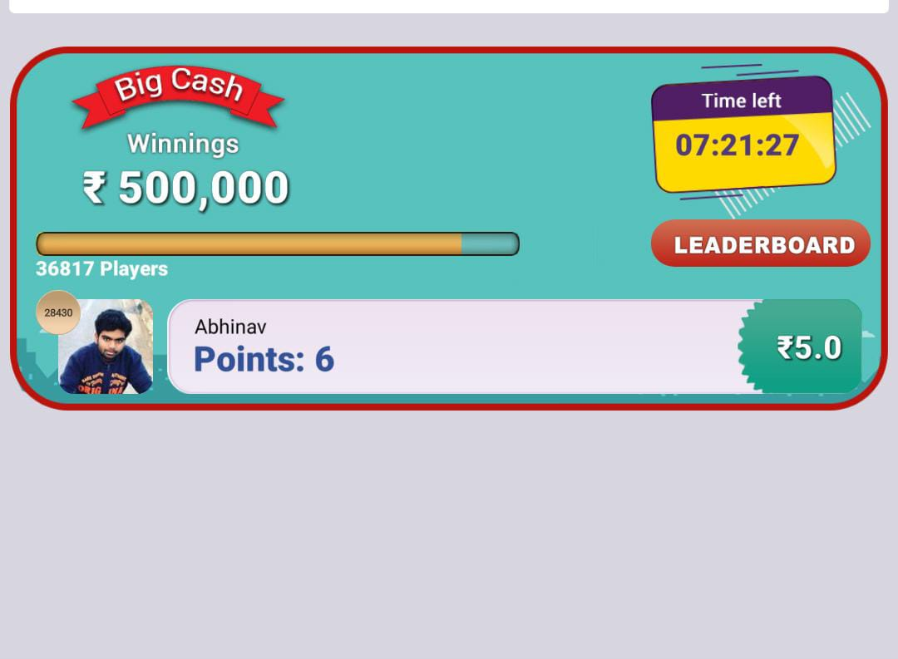

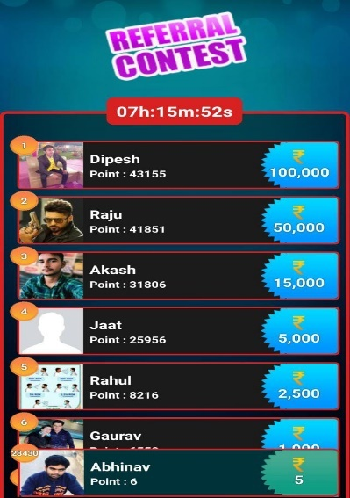**Step 4:** Click on the above banner to see the rank, points, and winnings of other users in referral contest.

### Prize Table (for Referral Contest).

|  |  |
| --- | --- |
| RANK | PRIZE |
| 1 | Rs. 100000 |
| 2 | Rs. 50000 |
| 3 | Rs. 15000 |
| 4 | Rs. 5000 |
| 5 | Rs. 2500 |
| 6 to 10 | Rs. 1000 |
| 11 to 50 | Rs. 500 |
| 51 to 100 | Rs. 100 |
| 101 to 200 | Rs. 60 |
| 201 to 500 | Rs. 25 |
| 501 to 1000 | Rs 10 |
| 1001 to 10000 | Rs. 8 |
| 10001 to 20000 | Rs. 6 |
| 20001 to 30000 | Rs. 5 |
| 30001 to 40000 | Rs. 4 |
| 40001 to 59000 | Rs. 3 |

### Terms and Condition

* Based on monthly leaderboard, prizemoney will be credited to winning amount within hours of contest completion.
* Tax of 31.2% will be deducted on winning of Rs. 10000 and above as per government regulations.

# CHAPTE 7: Redeem And BigCash Wallet

## Process

Open BigCash app

Open Menu and tap on Redeem

Check your wallet, your balance will be divided into two parts.

**Winning wallet** includes all your winning and can be directly redeem.

NOTE: For the first time user can redeem minimum Rs. 50.00 but there after minimum redeem amount will be Rs. 100.00 (FOR PAYTM WALLET).

**Unutilized wallet** refers to the amount deposited by you to participate in the game. The bonus amount as well as the token credits which are credited to your wallet are also reflected under utilized wallet. You cannot redeem from Utilized wallet but can use the same amount in participating in the game.

Choose the option to redeem (Paytm /UPI).

Enter the amount to redeem.

NOTE:

* 9% processing fee is applicable if the user redeems below Rs. 500.00
* 5% processing fee is applicable if the user redeems Rs. 500 or above.
* 9% processing fee is applicable for bloggers and youtubers for every redeem.

Enter and Re-enter Mobile no./UPI id and then tap on the redeem button.

Redeem Successful

**Step 1:** Open BigCash App.

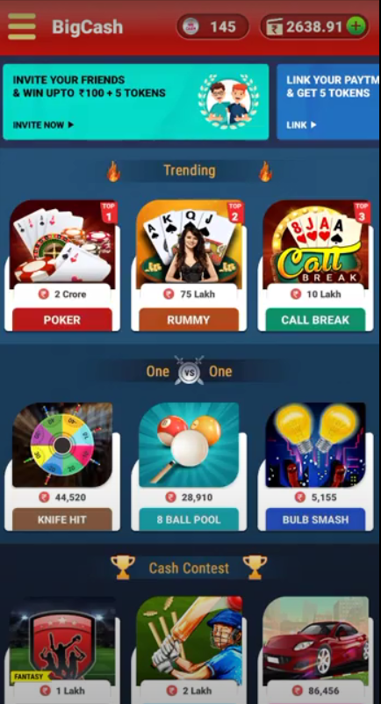

**Step 2:** Go to menu on top left corner and then go to Redeem.

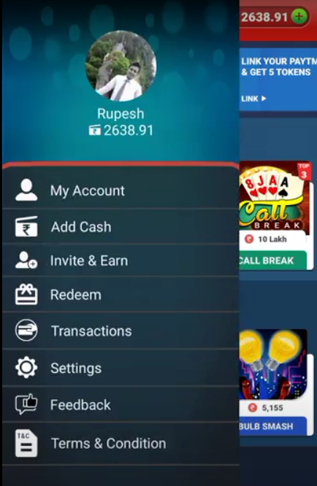

**Step 3:** choose the option to redeem by (paytm or UPI) and select the amount.

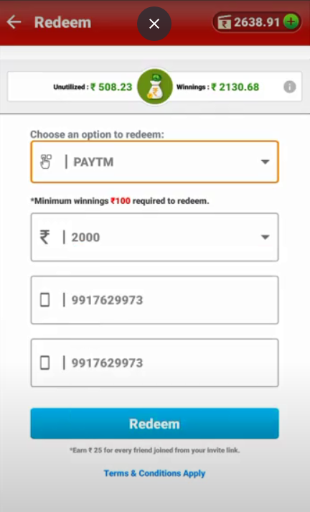

**Step 4:** Tap on redeem and amount will be credited in your account. (after deduction of redeem fee)

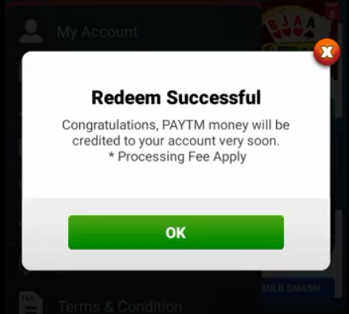 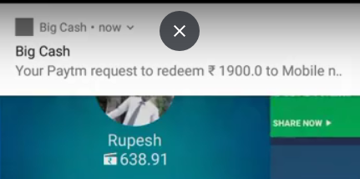

### Terms and condition for redeem

* Minimum Rs. 50 required for 1st redeem after that, minimum Rs 100 is required to redeem.​
* Maximum one redeem allowed in one day.​
* Processing fee is 9% if the redeem amount is less than Rs. 500 and processing fee is 5% if the redeem amount is more than 500.​
* For bloggers and youtubers, the processing fee is 9% on every redeem. (Referral winnings included)​

## BigCash wallets

**Big Cash Wallet is divided into 2 parts:**

**1. Money Wallet**

**2. Token Wallet**

**1. Money wallet** is further divided into 2 parts

**a) Unutilized Wallet:** This wallet reflects the amount deposited in your wallet by you for participating in the games.

The bonus amount as well as the token credits which are credited to your wallet are also reflected under the unutilized wallet.

This wallet is designed for you to enable participation in the games and therefore cannot be withdrawn.

**b) Winning Wallet:** You can withdraw your prize won by participating in cash games are reflected in your winning wallet.

2.**Token Wallet:** This wallet reflects the number of tokens user is having.

## Revenue model

Average 10% commission from every game

**Winning**

**Play**

User’s winning Wallet

(Rs. 18)

Our commission/ platform fee

(Rs. 2)

**Entry**

Rs.5/user

(4 player game)

Contest

Cricket

**User**